

Review of Seismic Guidelines and Reference Document
Summary of Submissions Received on the
Review Discussion Paper

27 June 2010

Document Ref no.: BPM-10-DOC-SP-v1.0
Table of Contents
1. Introduction 3
2. Methodology 3
3. Results 3
3.1 Submissions regarding content of the discussion paper 3
3.2 Summary of submissions received – sorted by submitter 3
4. References 3

List of Tables
Table 1: Summary of submissions received on content of the draft discussion paper and clarification from BPM where necessary. 3
Table 2: Summary of submissions received regarding the Guidelines, sorted by the person (organisation or institution) making the submission. 3

Appendix
Appendix 1 Submission – Chris Lalas (Marine Mammal Observer) 3
Appendix 2 Submission – Bill Armstrong (Todd Energy) 3
Appendix 3 Submission – Carol Sutherland (Marine Mammal Observer) 3
Appendix 4 Submission – Liz Slooten (University of Otago) 3
Appendix 5 Submission – Steven Benjamins (University of Otago) 3
Appendix 6 Submission – Will Rayment (University of Otago) 3
Appendix 7 Submission – Miriam Chote (MED / Crown Minerals) 3
Appendix 8 Submission – Deanna Clement (Cawthron Institute) 3
Appendix 9 Submission – Callum Lilley and Bryan Williams (DOC) 3
Appendix 10 Submission – Tim Allen (OMV) 3
Appendix 11 Submission – Ray Wood via John Pfahlert (GNS) 3

- Introduction
The New Zealand ‘Guidelines for Minimising Acoustic Disturbance to Marine Mammals from Seismic Survey Operations’ (the Guidelines) and associated Reference Document are under review. To facilitate the review, a draft discussion paper was prepared (BPM 2010). On May 25th 2010 a workshop was held in Wellington where the draft discussion paper was reviewed and a general discussion regarding the Guidelines and Reference Document held. The following people were in attendance at the workshop:
- John Pfahlert – PEPANZ – chair
- Laura Boren – Department of Conservation – scribe
- Dave Paton – Blue Planet Marine – presenting discussion paper
- Deanna Clements – Cawthron Institute
- Martin Cawthorn – MMO
- Bryan Williams – DOC Taranaki
- John Anderson – OMV
- Liz Slooten – Otago University
- Anshuman Chakraborty – DOC National Legal Team
- Kirstie Knowles – Forest and Bird
- Carol Sutherland - MMO
- Callum Lilley – DOC Taranaki
- Callum Kennedy – MED

Submissions on the discussion paper were sought. This paper summarises the submissions received.
- Methodology
Each submission received was distributed to BPM (David Paton), DOC (Laura Boren) and PEPANZ (John Pfahlert). BPM then collated and summarised the submissions. When summarising submissions, the upmost care was taken to avoid misinterpretation. The full submissions as received by BPM are appended to this document. In order to gain a complete understanding of the views submitted BPM recommends that these submissions are read in full.
Submissions on content of the discussion paper are outlined in Table 1; along with, where necessary, clarification from BPM on points raised.
The vast majority of comments and views received were not related to the discussion paper, but to the Guidelines themselves. These were summarised and formatted in a table; sorted by the date on which they were received and identified by the name of the person (or organisation/institution) making the submission (Table 2).

- Results
Eleven submissions were received. These are summarised below. The full submissions as received by BPM are appended to this document. In order to gain a complete understanding of the views submitted BPM recommends that these submissions are read in full.
  - Submissions regarding content of the discussion paper
Table 1: Summary of submissions received on content of the draft discussion paper and clarification from BPM where necessary.
No. | Summary of submission and BPM response (where necessary)
Chris Lalas – Marine Mammal Observer
1 | (Page 5 – Executive summary – last sentence) “In the absence of scientific data, international best practice appears to be a precautionary approach in the management of potential effects of seismic noise on marine mammals.”  - Dr Lalas: This statement is misleading, it implies definitive solutions exist. Given lack of scientific data, only true precautionary approach is to ban maritime seismic surveys. Should not pretend that regulations can reliably eliminate detrimental impacts.  - BPM Response: We believe the statement is accurate. The terms ‘best practice’ and ‘precautionary approach’ do not, in our opinion, indicate that solutions exist. They are simply management measures based on current knowledge of possible effects and are undertaken in order to mitigate possible effects. Perhaps an agreement by stakeholders on definitions for these terms would be helpful. BPM agrees that an understanding of the limitations of regulations is important.
2 | (Page 11 – 4.1 Comparison of marine mammal mitigation measures worldwide) “During normal operations, the UK, Australia, GOM, Brazil and Canada observe a 500 metre exclusion zone for all species covered in their guidelines. At 1 or 1.5 km, NZ’s exclusion zone is greater, but applies to ‘species of concern’ only. Australia applies a ‘sound exposure level’ criterion in determination of the appropriate exclusion zone.”  - Dr Lalas: This statement is a misrepresentation of regulations from other countries. It implies that NZ is amiss internationally and should change. (In his role as MMO, Dr Lalas applies the following: Australian regulations – 2 km low power zone requires power-down to lowest possible setting, “the consequence is the equivalent to a shutdown”. UK regulations – 500 m exclusion zone applies to pre- and soft-start observations, after soft-start has commenced, there is no exclusion zone.) Also, Australia’s regulations apply only to whales.  - BPM response: We believe the statement is factually accurate. BPM recommends that stakeholders read the relevant regulations and form their own conclusion. Row five of the table in Appendix 5 (pg 68) outlines the species to which various countries’ guidelines apply.
3 | (Page 25 – 8.1.1 Mandatory versus voluntary Guidelines) “Currently the Guidelines are not mandatory. Having voluntary guidelines can lead to inconsistencies and confusion in relation to their application. For example, some companies have chosen to apply only some components of the requirements. It is BPM’s understanding that NZ is the only country that has a formal set of guidelines which are not mandatory (see Appendix 5).”  - Dr Lalas: Having mandatory Guidelines will not necessarily avoid “inconsistencies and confusion”; problem can extend to companies not implementing the Guidelines.  - BPM response: Agreed. In theory mandatory Guidelines would not avoid inconsistencies and confusion; rather, it should ensure that the Guidelines are implemented. Simple, clear and transparent Guidelines would better aid in the avoidance of confusion and inconsistency regarding their application.
4 | - Dr Lalas: The two editing mistakes identified by the discussion paper (see section 8.2.9) should be “rectified immediately”.
5 | (Page 25 – 8.1.3 Practical considerations) “... it would be useful for DOC to provide flowcharts of actions for most, if not all, possible mitigation scenarios that might be encountered during seismic operations...”  - Chris Lalas: The existing Guidelines already supply a flowchart, which is good and Dr Lalas uses it and recommends others do too.  - BPM response: The Guidelines supply a table outlining recommended actions (Appendix 3). BPM’s suggestion is that a flowchart might be useful.
6 | Pages 26-27 – Review of ‘Species of concern’ and how the Guidelines apply to pinnipeds. “The literature review highlighted a lack of information regarding the effects of seismic surveys on pinnipeds. A possible modification to the Guidelines is to apply the Guidelines in full to ‘sea lion-like’ pinnipeds (sea lions and NZ fur seals) in areas that sea lions are known to frequent – Auckland Islands, Campbell Island, Otago Peninsula, Catlins, The Snares and Stewart Island – with a decent sized buffer around these areas consistent with known offshore foraging distances. In these areas where there is confusion as to whether a sighting is of a sea lion or fur seal, then the precautionary principle is applied and the assumption should be that it is a sea lion. The appropriate operational procedures would then be undertaken.”  - Dr Lalas: Following this inappropriate precautionary principle all unverified dolphin sightings should be treated as Hector’s or Maui’s dolphins. Unnecessary shut downs would result as would issues with MMO credibility. Easiest option is to address this issue at the survey planning stage, thus MMOs need not designate/negotiate resolutions. Dr Lalas does not call a shut down “unless/until I verify identification.”  - BPM response: We feel there has been a slight misunderstanding of this suggested possible modification to the Guidelines. This precautionary approach would be applied to locations where sea lions are known to frequent; specifically related to their known offshore foraging distances. As Dr Lalas states in his submission, sea lions in (for example) Otago forage over the continental shelf (generally within 12 nautical miles of the coast). The majority of seismic operations occur further offshore than this and so would not need to assume an unidentified pinniped was a sea lion. When operations do enter a prescribed location where sea lions probably forage, the precautionary principle would apply. The suggested approach is an attempt to balance protection of the NZ sea lion with as few unnecessary shutdowns as possible. BPM has witnessed different implementation of the Guidelines with respect to the issue of NZ fur seals and NZ sea lions and identifies this as a topic for further discussion.
7 | (Pages 28-29 – 8.2.7 Soft starts) “To minimise the acoustic impact on the environment, having a maximum period of 45 minutes for the soft start is a sound management procedure. However, there may be circumstances where the MMO could be consulted to determine options to extend the 45 minute period if it is deemed to have a lesser environmental impact rather than recommencing a full soft start. This decision should be based on a risk assessment and take into consideration the density and species of marine mammals detected in the region during recent operations.”  - Dr Lalas: MMOs must not be left with the responsibility of making decisions based on their interpretation of risk assessment. They could be open to pressure from company representatives. “… these sorts of issues must be raised and addressed at the planning stage of the survey.”
8 | (Page 31 – 8.2.11 Practice of using a single (whale or mitigation) gun during line turns).  - Dr Lalas: “The discussion paper does not mention the fact that the NZ Guidelines recommend the use of a mitigation gun during line changes.”
9 | (Page 11 – 4.1 Comparison of marine mammal mitigation measures worldwide). “All nations except the UK require continuous visual observation during daylight hours. At times of poor visibility or at night; Brazil does not allow operations, Canada requires and NZ recommends the use of Passive Acoustic Monitoring (PAM), and Australia only allows operations if three or fewer whale-instigated power- or shut-downs have occurred in the previous 24 hours.”  - Dr Lalas: “This statement is not really correct.” Many nations, including NZ, stipulate periods of observation during certain periods, e.g. before seismic operations begin, or allow cessation of visual observations during low visibility periods. Additionally, there is not necessarily a requirement to conduct visual observations during periods of transit or deployment/retrieval of gear.
10 | (Page 27 – 7.2 Technological advances)  - Dr Lalas: “The present list is biased towards PAM. Add Bipolarised radar [to the list]. The Australian Defence Science and Technology Organisation is developing a system to neutralise the effect of swell sea conditions on radar; promising preliminary results indicate that whales at the surface are visible on radar. This system is being developed with the aim of mitigating vessel collisions with whales.”
Bill Armstrong – Todd Energy
11 | - Marine mammals are not the only species that may require monitoring. Local stakeholders may have specific interests, such as Ngai Tahu’s interest in mutton birds. In the interest of good relations, industry should be prepared to accommodate this. Interest in other species should be mentioned in the discussion paper.
Deanna Clement – Cawthron Institute
12 | - There is often confusion over what the precautionary principle means. “…It would be nice to see some more examples of how other countries have interpreted the precautionary principle in the case of seismic scenarios.”  - BPM response: BPM are not aware of specific examples of seismic scenarios to assist in the understanding of how other nations have interpreted the precautionary principle. To our understanding, the best available information is the each nation’s Guidelines; hyperlinks to which are supplied at the top of page 67 of the discussion paper.
13 | - “…are there any preliminary results out of JIP research? If not what are the relevant deadlines as several issues that they are tackling are directly relevant to improving our guidelines. Could you list any relevant websites and/or discussion documents around this programme?”  - BPM response: The JIP website can be found at www.soundandmarinelife.org. Published and unpublished works of the JIP can be found here www.soundandmarinelife.org, under the heading “Research products of the JIP”. This page was last updated in December 2009.
14 | - Section 7.2 (Technological Advances) provided little information about how new technologies are able to address knowledge gaps nor which countries are currently using them. Discussion paper could include a list of citations or web site links or rank the “technologies in terms of their perceived or actual ability to help mitigate impacts in the future”.  - BPM response: Section 7.2 intended to show that new technology may assist in mitigating possible impacts on marine mammal rather than to address knowledge gaps. Appendix 5 of the discussion paper (page 70) highlights that the UK, Australia, GOM, Canada and NZ recommend the use of PAM. BPM does not have details, however, as to what proportion of companies in these regions apply this or the other technologies mentioned in the discussion paper.
Callum Lilley and Bryan Williams – DOC
15 | - “Seismic operations within the NZ Territorial Sea may require a permit under the Resource Management Act. Do you have the information to elaborate on this section? Are they generally required? If so, under what circumstances? If not, why haven’t they been required? Are conditions imposed to mitigate concerns regarding potential harm to marine mammals?”  - BPM response: Page 1, footnote 3 of the NZ Guidelines (DOC 2006a) state: “Please note that if you [seismic vessels] are operating in the Territorial Seas (coast – 12 nm) your operation may be subject to controls under the Resource Management Act 1991. Please contact the relevant Regional Council office and Department of Conservation office for advice.” BPM does not have specific information to answer your query and suggests that contact is made with Regional Councils or Planners within DOC.
16 | - “There are practical considerations regarding permitting systems (i.e., they could require a lot of unnecessary preparation or processing). How has the permitting system been received by industry overseas? Are these processes relatively streamlined?”  - BPM response: BPM are not aware of the practical details and requirements of permitting systems, nor of overseas industry opinion of them. This is outside of the scope of the discussion document.
17 | - “What is the genesis of this idea of “Permanent or Seasonal Importance” in Section 8.1.2? Could you elaborate on this a bit more with references to any international regime? Are you in a position to note that such areas could include Marine Mammal Sanctuaries in New Zealand?”  - BPM response: The NZ Guidelines refer to “Areas of Permanent Ecological Importance” and “Areas of Seasonal Ecological Importance”. The Reference Document (DOC 2006b), which supports the NZ Guidelines, outlines at page 4 that “Breeding, feeding, resting and migrating have been identified as important behaviours during which marine mammals are particularly vulnerable to disturbance (Environment Australia 2001). This is especially so for whales and dolphins accompanied by calves (McCauley et al 2000).” Where data were able to show that these behaviours occurred for some species in particular areas/times, these areas/times were designated as either of permanent or seasonal importance to said species. Tables of these areas/times are given at pages 5-6 of the Reference Document. As scientific knowledge grows it is intended that the lists of permanent and seasonally important areas/times be adjusted.

  - Summary of submissions received – sorted by submitter
Table 2: Summary of submissions received regarding the Guidelines, sorted by the person (organisation or institution) making the submission.
No. | Summary of submission
- Chris Lalas – Marine Mammal Observer
1a | - Current NZ Guidelines read at least as well as those from Australia and UK. They make sense and are achievable. Their shortfalls are outlined in the discussion paper.
1b | - Any certification and training of MMOs require quality control.
1c | - Regarding confusion about the statement in the Guidelines “Whale means all species commonly known as whale”: This definition is fine. It means any cetacean with a common name that ends in whale and covers almost all species longer than four metres, which includes almost all the vulnerable species (deep divers). What other options are there?
1d | - “We must have a quantitative definition for “low visibility” as a designated distance.” It does not appear to have been done elsewhere and doing so would remove discretionary decisions by MMOs.
1e | - Consistent with other nations, the Guidelines do not mention gun testing. “Should the Guidelines specify a locational restriction on the firing of guns (including mitigation gun)? For example, restricted to within 10? 20? km of the prospect area polygon. What is the maximum allowable gun volume allowed before gun tests must be preceded by a soft start?”
1f | - With respect to timing the end of soft starts as close as possible to the start of a line, the Guidelines could specify a maximum duration (e.g. 60 minutes between start of soft start and start of line). Could also consider specifications for the duration for which guns fire beyond end of line.
1g | - Regarding the Australian practice of determining the size of shut down zones depending on the acoustic properties and size of the seismic source: the size of shut down zones are determined during the planning stage of the survey so there is no issue for MMOs. Dr Lalas has been told that all seismic surveys exceed the 160dB re 1µPa2 s threshold and thus are subject to a 2 km low power zone, which “is a shut down without calling it a shut down … It’s just semantics to avoid calling it a shutdown (at maximum 3 shutdowns daily).” The only times seismic surveys possibly do not exceed the threshold are during low power (when a mitigation gun is used) and at the early stages of a soft start.
1h | - Steve Smith (DOC) informed Dr Lalas that the shutdown zone for a mitigation gun was the same as for full power operations. “Consequently I [Dr Lalas] recommend to company representatives to not use a mitigation gun during line changes because it can result in a shutdown (that can’t happen if the guns are off) and creates extra paperwork for all. This topic needs consideration.”
1i | - The lowest volume gun in the gun array is used as the mitigation gun. As the volume of gun arrays increases, so does the volume of the smallest gun; from about 20 cubic inches to 40 cubic inches in the last five years. How is this accounted for in the Guidelines?
1j | - Is the number of MMOs required during a survey and the hours they work per day affected by OSH regulations? If so, how is this reflected in the Guidelines?
1k | - The role of MMOs must be clearly defined and clear limits on extra duties set in order to not compromise their function.
- Bill Armstrong – Todd Energy
2a | - PEPANZ should be proactive in securing enforcement of acceptable guidelines rather than being reactive.
2b | - Present Guidelines look generally ok though some components should be excluded (see points 2b, 2c, 2d, 2e and 2g).
2c | - Pinnipeds should not be included in the Guidelines – they are small, difficult to see and numerous.
2d | - Due to lack of “research/repeatability of behavioral findings”, when seismic operations are conducted outside of marine reserves the Guidelines should apply only to cetaceans (whales, dolphins and porpoises). This was the original intent of the Guidelines. Special cases can be made for endangered species where seismic activity would overlap with breeding/feeding/migration areas, which have not been designated marine sanctuaries.
2e | - Use of PAM is expensive and controversial. There is a case for it to be used in marine parks but no hard evidence to suggest that its use in general waters is beneficial or even reliable. It should remain an option only in its use in open waters until further research demonstrates its benefits.
2f | - PAM could be installed at the Maari platform and will help further evaluation of it in the Taranaki region before it becomes mandatory.
2g | - One MMO assisted by trained crew members is sufficient for surveys of the size currently undertaken in NZ waters.
2h | - Marine mammals are not the only species that may require monitoring. Local stakeholders may have specific interests such at Ngai Tahu’s interest in mutton birds. In the interest of good relations, industry should be prepared to accommodate this.
- Carol Sutherland – Marine Mammal Observer
3a | - To be effective data collection needs to be standardised and the methods used by MMOs as objective as possible.
3b | - An agreed definitions/glossary is required and could include, amongst others, the terms: observing, ‘continual [observation], observing continuously.
3c | - Observer effort must be standardised.
3d | - Data collection must be standardised and a standardised (and shared) database established, which draws upon, but doesn’t blindly follow, examples from overseas. The presence of large numbers of fur seals in some areas needs to be considered in the design of said database. It is important that the database uses standardised fields which have clear definitions, and results in data of sufficient quality for scientific analysis. It needs to be coherent to and accepted by all, allow quick and easy input, be compatible to most operating systems and cover the fields that are required. MMOs should be able to input into the database from sea. A GIS component could be included. Examples of databases include ones produced by: Australian Antarctic Division (in construction) and JNCC.
3e | - Digital mapping of marine mammal sightings should be considered by those MMOs who use GPS to record sightings.
3f | - In order to generate reliable data and make accurate decisions regarding seismic operations, MMOs need to use accurate measures of distance to marine mammals. ‘Eye balling’ marine mammal distances is not acceptable. A review of the observation techniques used by MMOs would be prudent and a methodology for MMOs should be clearly outlined in the Guidelines.
3g | - Requiring MMOs to have the appropriate training should be investigated – preferably a course specific to Australasia.
3h | - Since MMOs are paid by and answerable to seismic acquisition companies, they may be perceived as influenced by the company’s best interests. An accreditation system, assessing qualifications and observer methods, and perhaps run by DOC, may help to dispel this perception.
- Liz Slooten – University of Otago
4a | - Guidelines should be mandatory and adherence to them should be monitored by independent or Government observers.
4b | - In order to reduce the risk of impacts by seismic surveys on marine mammals, a pre-survey EIA process should be mandatory.
4c | - An EMP outlining measures to avoid undue impacts on marine mammals and other species should be required for each survey and include a “worst-case assessment of sound propagation under likely oceanographic and weather-related conditions at the time of survey”. The precautionary principle should be applied where data are not available.
4d | - The Guidelines should require seismic survey operators to undertake appropriate consultation with other interest groups (commercial, environmental and scientific). Such groups may hold information/data valuable for assessing impacts.
4e | - Absence of adequate baseline data makes it virtually impossible to accurately assess the impacts of seismic surveys on marine mammals. The Guidelines should require independent research undertaken before and after seismic operations. This research should be funded by industry via a levy to DOC (or other independent agency). DOC should manage and enforce this requirement and administer the resulting data, which should be publicly available.
4f | - In addition to visual surveys, the use of PAM – before, during and after surveys – should be mandatory. Static or pop-up acoustic detectors would allow for such acoustic requirements. Towed and static hydrophone arrays should be used (towed arrays having the capability to record marine mammal sounds) and hydrophone arrays should also be towed by other research vessels and placed on the sea floor.
4g | - MMOs need to be trained and certified to international standards by an independent agency in all aspects of monitoring impacts of seismic operations on marine species, including; marine mammal identification, current conservation regulations and proper seismic survey operations. Inexperienced MMOs should be mentored by experienced MMOs and work in a variety of environmental conditions before working independently or as a senior MMO.
4h | - In order to avoid conflicts of interest, MMOs should be completely independent, i.e. not employed by the operator. DOC or another agency should manage industry payment for MMOs and other environmental monitoring.
4i | - Debate exists regarding the effectiveness of the ‘soft start’ or ‘ramp-up’. If this procedure is to be retained in the Guidelines, research should be undertaken to assess whether it works.
4j | - The practice of firing airguns during line turns should be reconsidered and appropriate at-sea tests carried out to determine its effectiveness.
4k | - Since the probability of observing marine mammals during poor sighting conditions (high seas, fog, heavy rain, nighttime) is low, the Guidelines should specify that surveys not be carried out under such low-visibility conditions or at night.
4l | - The Guidelines should specify the minimum number of MMOs required per survey and the number of hours of work per day. At least two MMOs should be on watch at all times during daylight hours, regardless of whether airguns are being used or not as this will provide important comparative data. This will require a team of at least 4 observers, allowing MMOs to rotate through a schedule of watches (e.g. on one hour, off one hour or similar).
4m | - The distance of 1.5 km appears to have been adopted because this is the maximum distance at which MMOs are able to detect marine mammals reliably. Professional equipment (such as big-eye binoculars as used on US National Marine Fisheries Service surveys) can allow detection up to about 6 nautical miles away given good sighting conditions and experienced observers.
4n | - Literature suggests that airguns are audible to marine mammals at a distance of at least 80 km. MMOs positioned on the seismic vessel (as per the Guidelines) will, thus, likely miss detecting initial potentially harmful reactions from marine mammals (displacement etc). MMOs need to be on a separate vessel or aircraft in order to detect marine mammals in time, before they respond to the airguns.
4o | - Until better data are available on each marine mammal species in terms of population size, distribution and vulnerability to seismic surveys, the Guidelines should apply to all marine mammal species until such time as science-based distinctions on applicable species can be made.
4p | - The effects of seismic surveys on other species that dive for food (e.g. turtles and seabirds) are not well known and could be of concern. This may be especially important for uncommon species (e.g. yellow-eyed penguin, Fiordland crested penguin). Areas frequented by large concentrations of such species should be considered as ‘Areas of Ecological Importance’ to avoid excessive exposure to seismic survey noise.
4q | - The Guidelines do not consider the potential effects on marine mammals and seabirds of widespread relocation, behavioural change or injury of their prey species resulting from seismic surveys. These second-order impacts need to be considered when undertaking a risk assessment of any seismic survey before it is allowed to proceed.
4r | - Though the inclusion in the Guidelines of Exclusion Zones is laudable, it is difficult or impossible for an MMO to determine species ID or the presence of a calf at a distance of 1-1.5 km. This distance makes no biological sense, given that air guns are audible for many tens of kilometers. Exclusion Zone dimensions in other countries were based on sound wave modeling work or tests of captive animals; however, recent research has shown that airgun sounds are detectable over far greater distances, and at much higher intensities, than was previously predicted.
4s | - If the term ‘calf’ is to be retained in the Guidelines it should be given an unambiguous definition.
4t | - Exclusion Zones, shut down procedures, etc. should be used for all species of marine mammals, not just for ‘Species of Concern’. The guidelines should be revised in such a way that regulations apply equally to all marine mammal species.
4u | - The Guidelines should be regularly revised in order to incorporate changes in the status of ‘Species of Concern’, and ‘Areas of Ecological Importance’.
4v | - MMOs should use a standardised data recording sheet. This should include: detailed information about vessel operations, observation effort, and any recorded sightings/acoustic observations of marine mammals or other species of interest. Such sheets have been developed by E&P Sound and Marine Life Joint Industry Programme and JNCC.
4w | - All MMO data gathered in New Zealand waters should be submitted to a centralised database managed by DOC as a web portal accessible to the general public.
4x | - Although making observations from seismic vessels has serious limitations, data gained by MMOs and via PAM should be used to; broaden understanding of seasonal distribution of marine mammals, identify migration routes and broad-scale habitat use (e.g. calving areas), increase knowledge re marine mammal vocalisations, improve acoustic species recognition techniques, provide data on sighting probability and behavior of animals around seismic vessels at different sound levels, and generally provide insight into the impacts of seismic surveys on these species.
4y | - Seismic noise is audible much further than MMOs can see. The existence of Guidelines therefore provides a false sense of security, implying that significant harm can be prevented as a result of mitigation measures instigated by the MMO (e.g. monitoring of Exclusion Zones, soft-start procedures, etc). In reality, the existing guidelines provide very little assurance that all relevant marine mammal species would be seen by MMOs, nor that appropriate action would be taken to avoid or reduce the impact.
4z | - The Guidelines do not address issues of effective observation and interpretation of marine mammal responses to seismic sources, thus, they are unlikely to prevent significant impacts of seismic surveys on marine mammals and other species beyond the immediate vicinity of the sound source. These populations may be under additional pressures such as pollution and bycatch. Additional research is required.
4aa | - The likely environmental impacts of mining (as well as exploration itself) should be taken into account in decisions as to whether exploration should take place.
4ab | - The Guidelines should be part of an over-arching management scheme that includes various components such as avoiding seismic surveys by exploring alternative energy sources and methods of exploration, and avoiding areas with vulnerable species e.g. sperm & beaked whales. Seismic surveys in areas with no vulnerable species should have a full and credible research programme.
4ac | - “Credible systems of acoustic and visual observations should be instituted, and the sighting probability of the combined efforts of visual and acoustic methods should be estimated for a range of species and distances from the seismic vessel.”
4ad | - “An important priority for NZ is to carry out marine mammal surveys on which to base decisions on areas where exploration could take place using airguns, and areas where exploration should not take place or should use more modern, less environmentally damaging technology.”
- Steven Benjamins – University of Otago
5a | - Voluntary guidelines risk improper and/or incomplete application, or may not be applied at all by operators. Guidelines should be mandatory and adherence to them should be monitored by independent or Government observers.
5b | - In order to reduce the risk of impacts by seismic surveys on marine mammals, a pre-survey EIA process should be mandatory.
5c | - An EMP outlining measures to avoid undue impacts on marine mammals and other species should be required for each survey and include a “worst-case assessment of sound propagation under likely oceanographic and weather-related conditions at the time of survey”. The precautionary principle should be applied where data are not available. Management strategies must be able to respond quickly to observed changes in animal behaviour/distribution and flexible so that present and future surveys can be adjusted accordingly.
5d | - The Guidelines should require seismic survey operators to undertake appropriate consultation with other interest groups in order to identify areas where interests overlap.
5e | - Absence of adequate baseline data makes it virtually impossible to accurately assess the impacts of seismic surveys on marine mammals. The Guidelines should be updated to reflect the need for survey coverage prior to and following seismic surveys, using standard marine mammal surveying protocols, as a condition to obtaining a ‘survey license’. This research should be funded by industry via a levy to DOC (or other independent agency). DOC should manage and enforce this requirement and administer the resulting data, which should be made publicly available.
5f | - MMOs need to be trained and certified to international standards by an independent agency in all aspects of monitoring impacts of seismic operations on marine species, including; marine mammal identification, current conservation regulations and proper seismic survey operations. Inexperienced MMOs should be mentored by experienced MMOs and work in a variety of environmental conditions before working independently or as a senior MMO.
5g | - MMOs should be dedicated to their tasks (i.e. not have additional or conflicting work requirements).
5h | - In order to avoid conflicts of interest, MMOs should be completely independent, i.e. not employed by the operator. DOC or another agency should manage industry payment for MMOs and other environmental monitoring.
5i | - Debate exists regarding the effectiveness of ‘soft start’ or ‘ramp-up’. If this procedure is to be retained in the Guidelines, research should be undertaken to assess whether it works.
5j | - The Guidelines should be amended to include a 60-minute pre-shoot watch prior to seismic acquisition in offshore waters. Deep diving species (e.g. sperm whales and beaked whales) are more likely to frequent these areas and as they dive for periods greater than the 30 minute pre-shoot watch may not be detected.
5k | - In the current Guidelines, the characteristics required for using airguns during line turns or changes to deter marine mammals from an area are not specified, potentially leading to unnecessarily high levels of exposure. It is also not clear whether this technique is always successful, as in some cases animals may be attracted to single airguns or exhibit vertical avoidance of higher sound levels at depth by surfacing near the array. For these reasons, the requirement to use airguns as a deterrent during all turns should be reconsidered, and appropriate at-sea tests carried out to determine the effectiveness of this method.
5l | - Since the probability of observing marine mammals during poor sighting conditions (high seas, fog, heavy precipitation) is low, the Guidelines should specify that surveys not be carried out under such low-visibility conditions.
5m | - The inclusion of the 1-1.5 km Exclusion Zones is welcomed. The Zones should apply to all marine mammal species, however, not only Species of Concern. The same holds for protocols around shut downs; regulations should apply to all marine mammal species, not just ‘Species of Concern’.
5n | - The Guidelines should “address impacts or disturbance associated with seismic surveys other than airgun noise, including disturbances caused by auxiliary or support vessels. Such potential impacts should also be considered during a formal pre-survey EIA process.”
5o | - The revised Guidelines should take practical considerations into account and stipulate minimum numbers of MMOs and maximum working hours per day, without compromising on the requirement to monitor all relevant seismic survey activity, 24 hr/day.
5p | - The Guidelines presently are insufficiently specific in terms of the species of marine mammals that are covered by them; some rules apply to all marine mammal species while others apply only to ‘Species of Concern’. “… it is not obvious whether particular species of cetaceans commonly known as ‘whales’ (e.g. false killer whales, melon-headed whales and pygmy sperm whales) are to be considered as ‘Species of Concern’ under the current Guidelines … it is not clear why some delphinids (killer whale, pilot whale) would be judged by a different standard from others based on overall conservation status in New Zealand waters. Impacts on specific populations of other delphinid species could be equally serious, while some of these relatively abundant species may even show stronger reactions to seismic surveys. Since additional regulations apply when ‘Species of Concern’ are involved, the list of ‘Species of Concern’ needs to be reviewed. In the meantime it makes sense to clarify that all cetacean species (whales, dolphins and porpoises) are included under the Guidelines.
5q | - The current requirement for shut down when a ‘Species of Concern’ with a cow/calf pair is problematic for the following reasons: difficult or impossible for MMOs to detect a calf at 1.5 km, the term calf needs an unambiguous definition so as to avoid interpretation, airguns are audible for distances much greater than 1.5 km and so conservation benefits are debatable.
5r | - The distance of 1.5 km appears to have been adopted because this is the maximum distance at which MMOs are able to detect marine mammals reliably. Professional equipment (such as big eye binoculars as used on US National Marine Fisheries Service surveys) can allow detection up to about 6 nautical miles away given good sighting conditions and experienced observers.
5s | - Potentially significant impacts on marine mammals and other species may be undetected because the animals are beyond the observable area of the principal MMO on the seismic vessel. “Concurrent observations by other MMOs are therefore required on a separate vessel or aircraft away from the seismic vessel in order to detect marine mammals in time, before they respond to the airguns. A more biologically relevant Exclusion Zone might be defined by identifying a zone of minimum sound intensity around the vessel, within which Exclusion Zone regulations apply. The dimensions of such an Exclusion Zone would differ from survey to survey, depending on local oceanographic conditions, airgun parameters, etc.”
5t | - It seems incongruous that the Guidelines apply to one pinniped species NZ sea lions (a ‘Species of Concern’) and not another (NZ fur seals). These species are difficult to distinguish at sea and since sea lions are reoccupying more of their historic range, the locations where both species can be confused will only increase. Given the general lack of information about the impact of seismic surveys on pinnipeds, a more precautionary approach would be to include all pinniped species on the list of species covered under the Guidelines. This will also include several species of seals more common in subantarctic waters, but which are occasionally reported off mainland New Zealand (specifically leopard seal and southern elephant seal), which are presently not covered under the Guidelines.
5u | - The effects of seismic surveys on other species that dive for food (such as turtles and seabirds) are not well known and could be of concern. This may be especially important for uncommon species (e.g. yellow-eyed penguin, Fiordland crested penguin). Areas frequented by large concentrations of such species should be considered as ‘Areas of Ecological Importance’ to avoid excessive exposure to seismic survey noise.
5v | - Five species of marine turtles visit NZ waters, at least occasionally. Though poorly understood, their distribution and abundance is greater in waters to the north of the North Island. The leatherback turtle, however, has been reported as far south as Otago. All species of marine turtle are listed as Threatened by the International Union for Nature Conservation (IUCN), and are included under seismic survey guidelines set up for marine mammals in several jurisdictions (e.g. UK, USA, Brazil, Canada). Given their conservation status and the lack of knowledge of impacts of seismic surveys on them, a precautionary approach would be to include all marine turtle species on the list of species covered under the New Zealand Guidelines. There is the additional risk of injury or mortality of marine turtles that get entangled in cables associated with the towed airgun arrays, and preventative gear modifications may be necessary in areas where turtles are encountered regularly.
5w | - The Guidelines do not consider the potential effects on marine mammals and seabirds of widespread relocation, behavioural change or injury of their prey species resulting from seismic surveys. These second-order impacts need to be considered when undertaking a risk assessment of any seismic survey before it is allowed to proceed.
5x | - The Guidelines should be regularly revised in order to incorporate changes in the status of ‘Species of Concern’, and ‘Areas of Ecological Importance’.
5y | - MMOs should use a standardised data recording sheet. This should include: detailed information about vessel operations, observation effort, and any recorded sightings/acoustic observations of marine mammals or other species of interest. Such sheets have been developed by E&P Sound and Marine Life Joint Industry Programme and JNCC.
5z | - All MMO data gathered in New Zealand waters should be submitted to a centralised database managed by DOC as a web portal accessible to the general public. “Access to this dataset should be managed through an authentication system supervised by a system administrator. In time, additional data from other sources associated with anthropogenic sound production (e.g. site-based or borehole surveys, marine construction, military exercises) might also be added to this database. Several elements that would need to be considered when developing this database include:  1. developing a formal protocol for data analysis and publication;  2. deciding how to manage confidential or commercially sensitive data;  3. addressing issues of data ownership;  4. using MMO data to determine operators’ degree of compliance with regulations;  5. agreeing on the correct interpretation of data from different sources, taking into account different collection methodologies;  6. developing a confidence assessment protocol;  7. including a peer review process when analysing data and publishing results;  8. addressing questions of data storage, security and quality control.”
5aa | - Although making observations from seismic vessels has serious limitations, data gained by MMOs and via PAM should be used to; broaden understanding of seasonal distribution of marine mammals, identify migration routes and broad-scale habitat use (e.g. calving areas), increase knowledge re marine mammal vocalisations, improve acoustic species recognition techniques, provide data on sighting probability and behavior of animals around seismic vessels at different sound levels, and generally provide insight into the impacts of seismic surveys on these species.
5ab | - Seismic noise is audible much further than MMOs can see. The existence of Guidelines therefore provides a false sense of security, implying that significant harm can be prevented as a result of mitigation measures instigated by the MMO. In reality, the existing Guidelines provide very little assurance that all relevant marine mammal species would be seen by MMOs, nor that appropriate action would be taken to avoid or reduce the impact.
5ac | - The Guidelines do not address issues of effective observation and interpretation of marine mammal responses to seismic sources, thus, they are unlikely to “prevent widespread significant impacts of seismic surveys on marine mammals and other species beyond the immediate vicinity of the sound source”. Additional research is required.
5ad | - “At present, the most successful impact mitigation strategy would be spatiotemporal avoidance of areas where marine mammals or other sensitive species are likely to be encountered, taking a precautionary approach where data are unavailable, and bearing in mind the need for regular updating of data due to climate change-induced distribution shifts of species.”
5ae | - “It is important that the limitations of management actions as described in the current Guidelines are clearly understood, to avoid a false sense of security that conservation objectives in the wider marine environment are being met through their application…”
5af | - “At a broader level, the present Guidelines should be embedded in an overarching governmental marine area management scheme that, among other things, minimises the exposure of marine ecosystems to acoustic seismic exploration where possible.” This scheme should consist of components including; reducing the need for use of seismic surveys by continued development of renewable energy resources and alternative exploration methods, conducting research to assist in more sound management decisions, avoiding surveys in areas suspected of containing high densities of marine mammals, and incorporating credible research programmes with seismic surveys.
- Will Rayment – University of Otago
6a | - Guidelines must be mandatory. This would bring NZ into line with other countries, ensures standards and introduces legal obligation to adhere to the standards.
6b | - To determine if a survey will occur in critical habitat/at critical times, a pre-survey EIA should be required. The results of the EIA should determine whether the survey progresses and if so, any special considerations.
6c | - Gaps in knowledge of marine mammal abundance and distribution should be addressed before surveys can take place.
6d | - MMOs need to be trained and certified by an independent agency and to international standards (tailored for NZ) in; marine mammal identification, operation of acoustic equipment and seismic survey protocols. Inexperienced MMOs should be mentored by experienced MMOs and work in a variety of environmental conditions before working independently or as a senior MMO.
6e | - “Hiring and placement of MMOs should be undertaken by an independent body to ensure no conflict of interest.”
6f | - “Appropriate numbers of MMOs are required to monitor seismic survey operations. Surveys can operate for more than 12 hours per day over multiple days or weeks. It is not feasible for a single MMO to maintain a high level of reporting accuracy over these durations, and so teams of MMOs may be required. Guidelines concerning a maximum number of working hours per day and a maximum number of consecutive working days should be devised in order to achieve suitable MMO coverage.”
6g | - “…visual observations are only reliable if strict limits are placed on sighting conditions. Visual observations should not be relied upon in low light, fog or rough weather.”
6h | - Visual observations and PAM should be used. These are often complementary and together can increase detection rates, especially for long-diving species.
6i | - “Data collection forms should be standardised and brought into line with international best practice (e.g. JNCC). This will facilitate analysis and archiving of the data.”
- Miriam Chote – MED / Crown Minerals
7a | - Crown Minerals will not make recommendations until the next step in the process.
- Deanna Clement – Cawthron Institute
8a | - Please refer to Table 1 for Dr Clement’s comments; all comments were specific to the discussion paper rather than the Guidelines themselves.
- Callum Lilley and Bryan Williams – DOC
9a | - It is important to remember that Marine Mammal Sanctuary Regulations are legally binding and there can be legal consequences for not following them. Also, there may be consequences for not following the Guidelines in terms of damage to a company’s public image through public/media criticism etc.
- Tim Allen – OMV
10a | - Adequate funding is required for robust research and subsequent development of acceptable seismic acquisition practices. Industry should fund some research.
10b | - Guidelines should be mandatory.
10c | - OMV currently provides the equivalent of an EIA in their HSE Plans, so making mandatory the provision of a pre-survey EIA would not greatly affect them. However, lack of publicly accessible environmental information would likely see resistance from industry in general. For greater industry acceptance the following should be addressed (see 10d, 10e, 10f, 10g, 10h):
10d | - Marine mammal sighting reports are not accessible. Access to a suitable online database will help with analysis of species distribution. DOC does not have resources to create this database and populate it with historical data. OMV previously offered to financially assist this work, which was potentially to be undertaken by the Bay of Plenty Polytechnic.
10e | - There is no defined format for submission of MMO sighting reports, apart from a one page DOC form. Establishing an online portal for direct entry by MMOs would facilitate efficient uploading of data, without a significant effort by DOC (or whoever maintains the database).
10f | - The DOC-maintained historical whale strandings database should be incorporated into a national marine mammal database.
10g | - Should DOC maintain the national marine mammal database? Would it sit with the Ministry of Fisheries, whom maintain the National Aquatic Biodiversity Information System (NABIS)?
10h | - Given present funding cuts “It is unreasonable to expect DOC to be the administrator of a national marine mammal database or to process seismic EIAs. Industry must be prepared to accept a suitable level of "user pays".”
10i | - During a recent seismic survey undertaken by OMV in the Great South Basin and employing visual (MMO) and PAM monitoring for marine mammals, “Only one of the disruptions to operations was initiated by PAM. When the cost of PAM equipment and operators is taken into account, the total increase in survey costs attributable to the use of PAM was 0.85%. The increase in costs is therefore negligible when compared to the potential implications of a stranding or public perception that the industry does not take this issue seriously.”
10j | - Because the impact of seismic operations on marine mammals has not been unequivocally proven, some may see the use of PAM as unwarranted. An acceptable compromise could be to:  1. Accept mandatory use of PAM within present marine mammal sanctuaries (as per present Guidelines); and  2. Accept mandatory use of PAM when acquisition is to occur on documented migration routes during migration periods.  - Item 2 above will encourage planning around migration periods. Establishment of a suitable marine mammal database will be necessary before item 2 will be accepted.
10k | - “It is OMV practice to have multiple MMOs and PAM operators on board a seismic vessel. In addition to the effectiveness of observers, there are HSE implications of staff working long hours (especially in the southern ocean during summer) for prolonged periods.”
- Ray Wood (via John Pfahlert) - GNS
11a | - “[The Guidelines]… makes no allowance for smaller scale research seismic reflection profiling and, like the Marine Sanctuaries Act, it draws up rules (leading towards law) that will apply to all scales … The guidelines for smaller scale surveying are unnecessarily onerous and generally make such surveying impracticable. The effect of the Marine Sanctuaries Act and these proposed guidelines are to either dissuade surveyors from undertaking crucial seismic surveying (e.g. for coastal engineering purposes, scientific studies) or to have them breaking the law …The guidelines need to include an allowance for smaller scale seismic than those typically used for petroleum exploration.”

- References
BPM 2010. Review of Seismic Guidelines and Reference Document Discussion Paper. Prepared for Department of Conservation, 19 May 2010. Document Reference No. BPM-10-DOC-DP-v1.0. 76pp.
DOC (2006a) Guidelines for minimising acoustic disturbance to marine mammals from seismic surveys. Department of Conservation, Wellington, New Zealand.
DOC (2006b) Reference Document: Guidelines for minimising acoustic disturbance to marine mammals from seismic surveys. Department of Conservation, Wellington, New Zealand.

Appendix 1
Submission – Chris Lalas (Marine Mammal Observer)

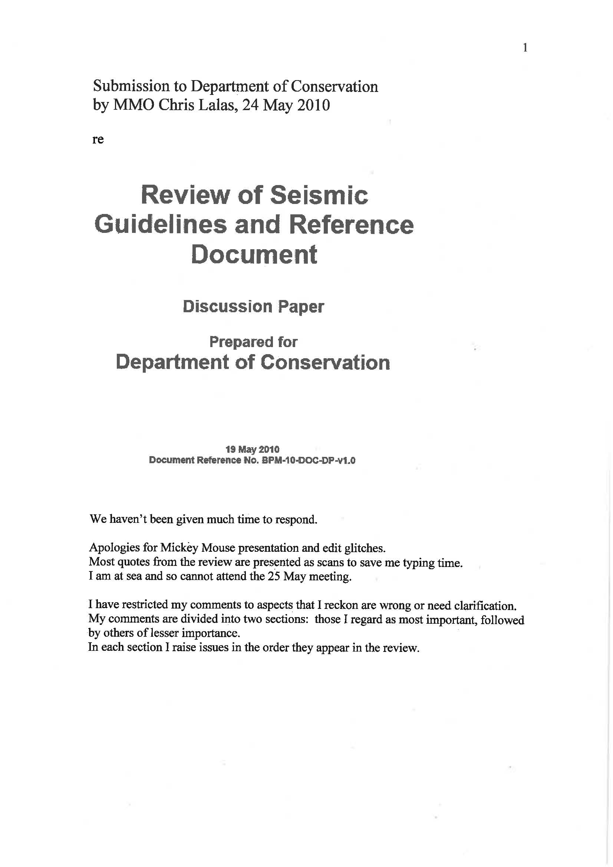

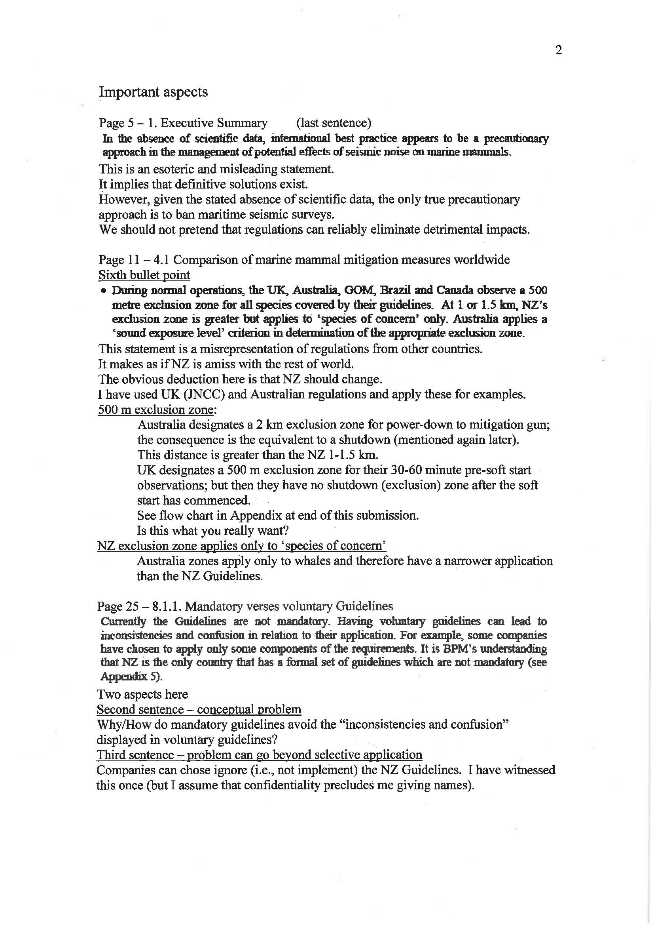

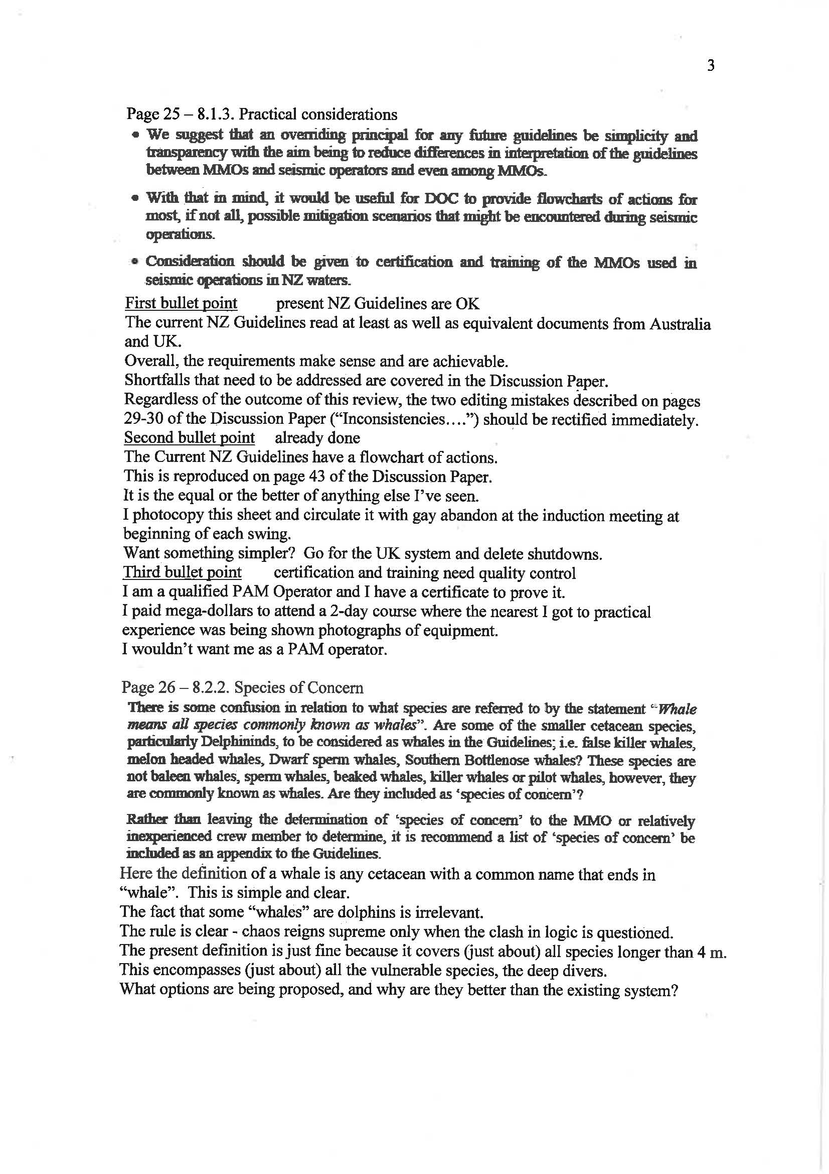

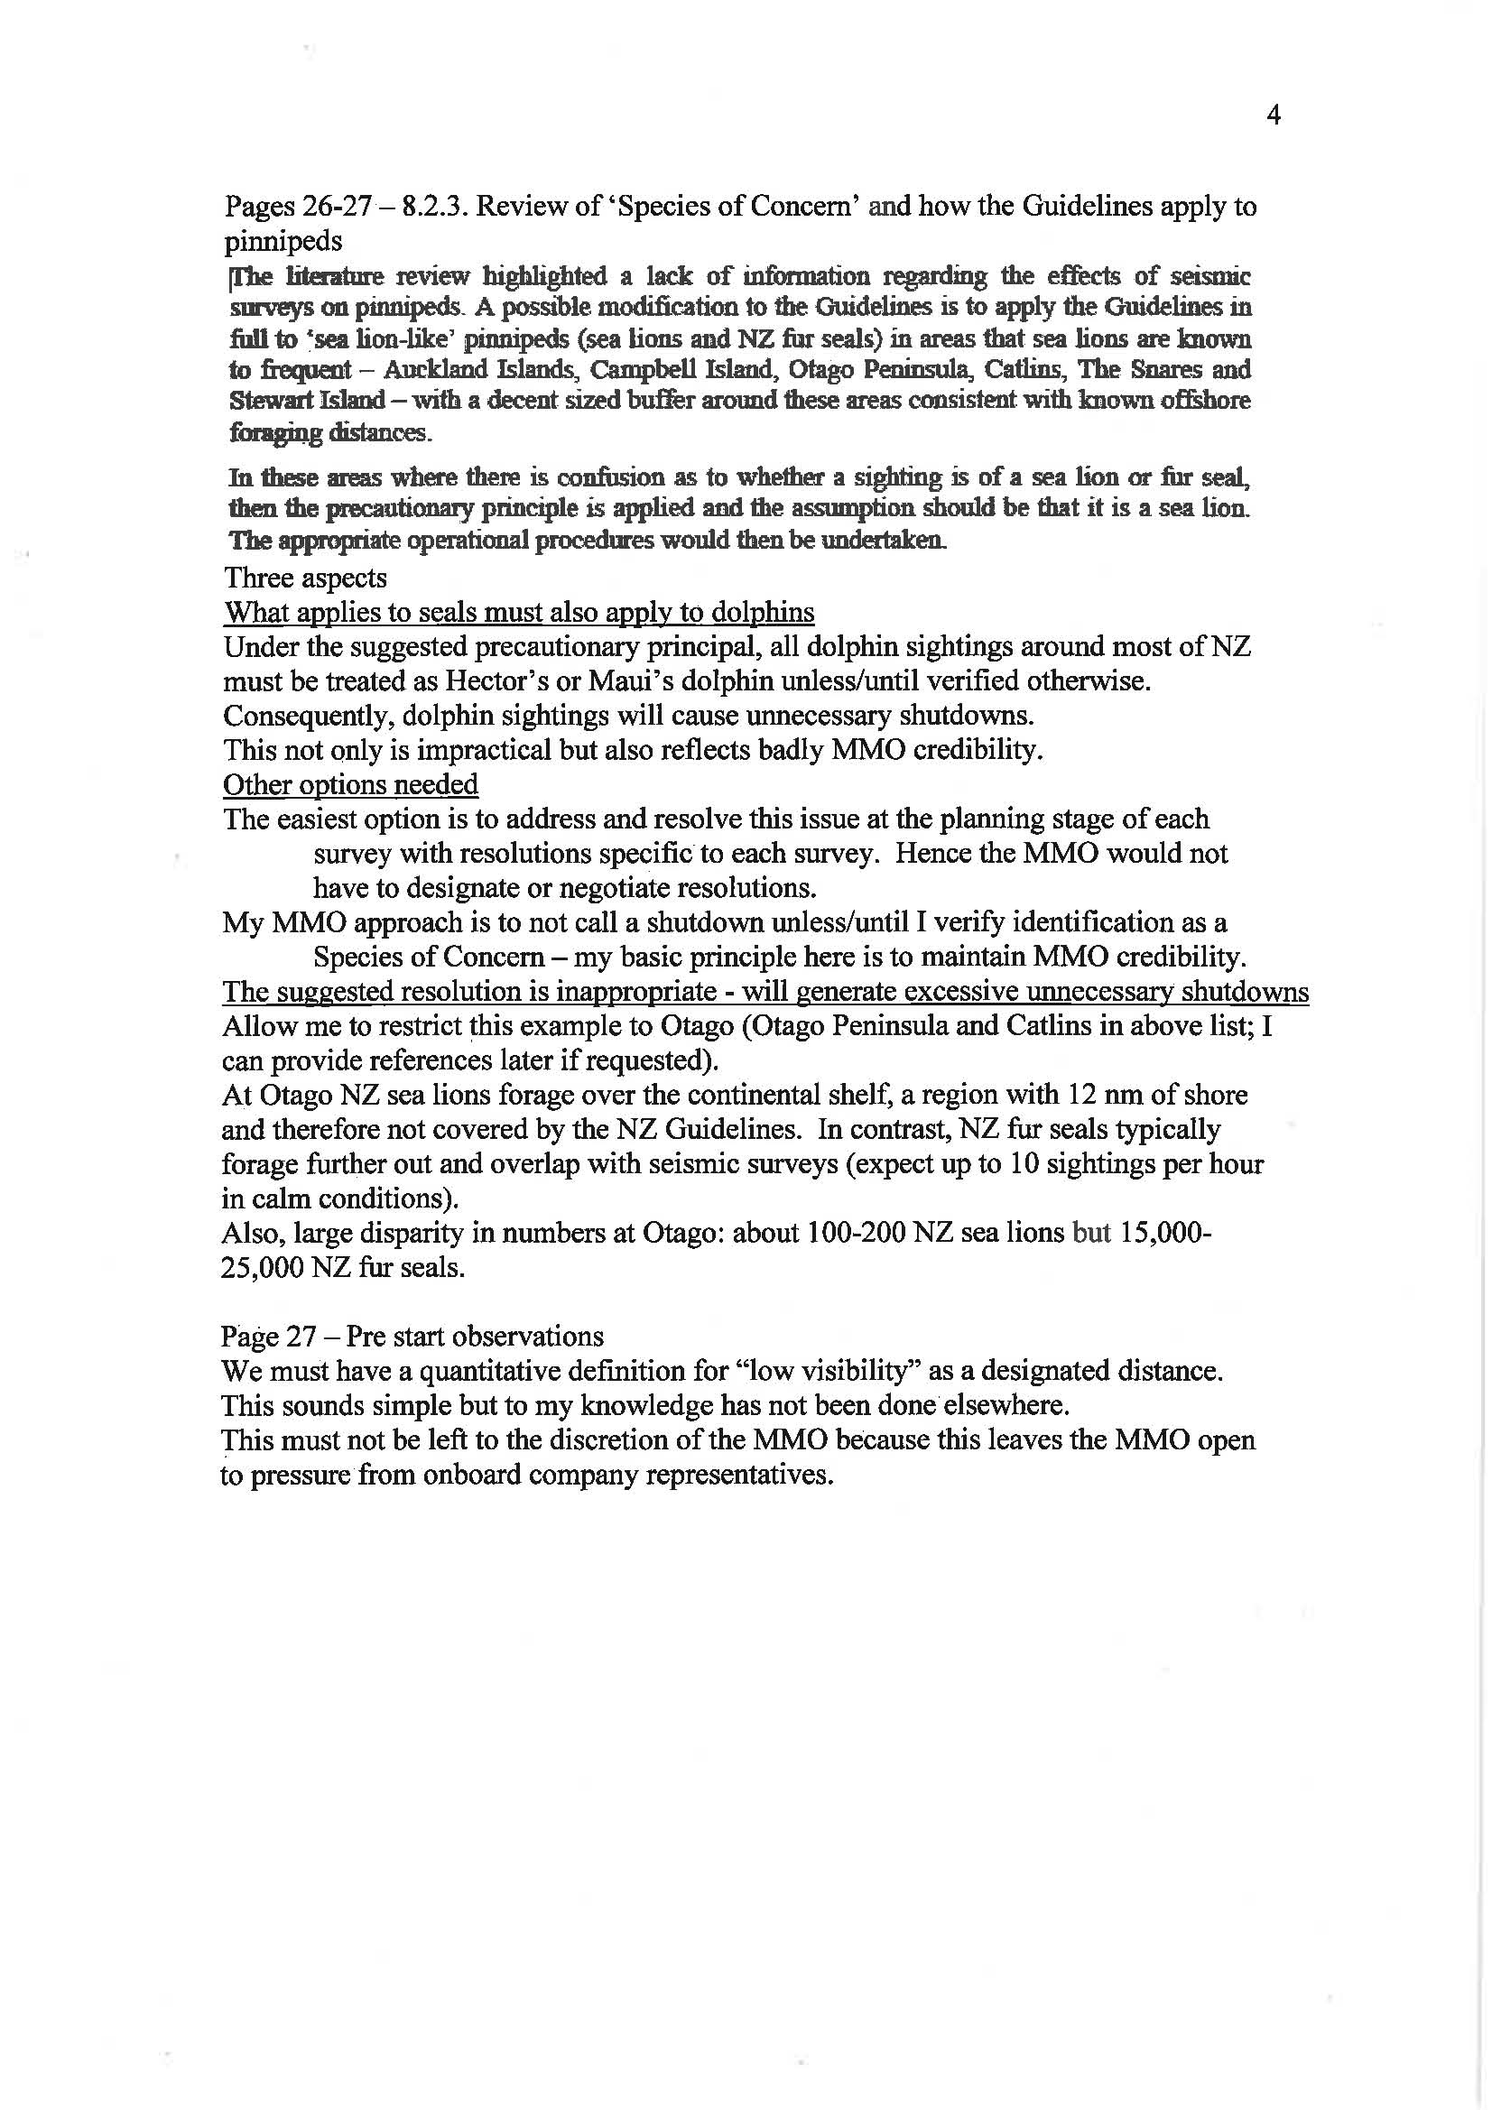

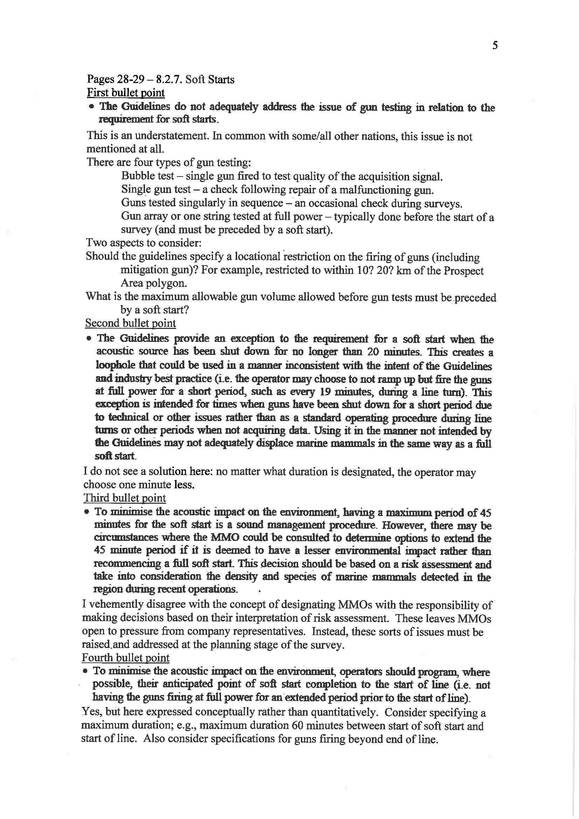

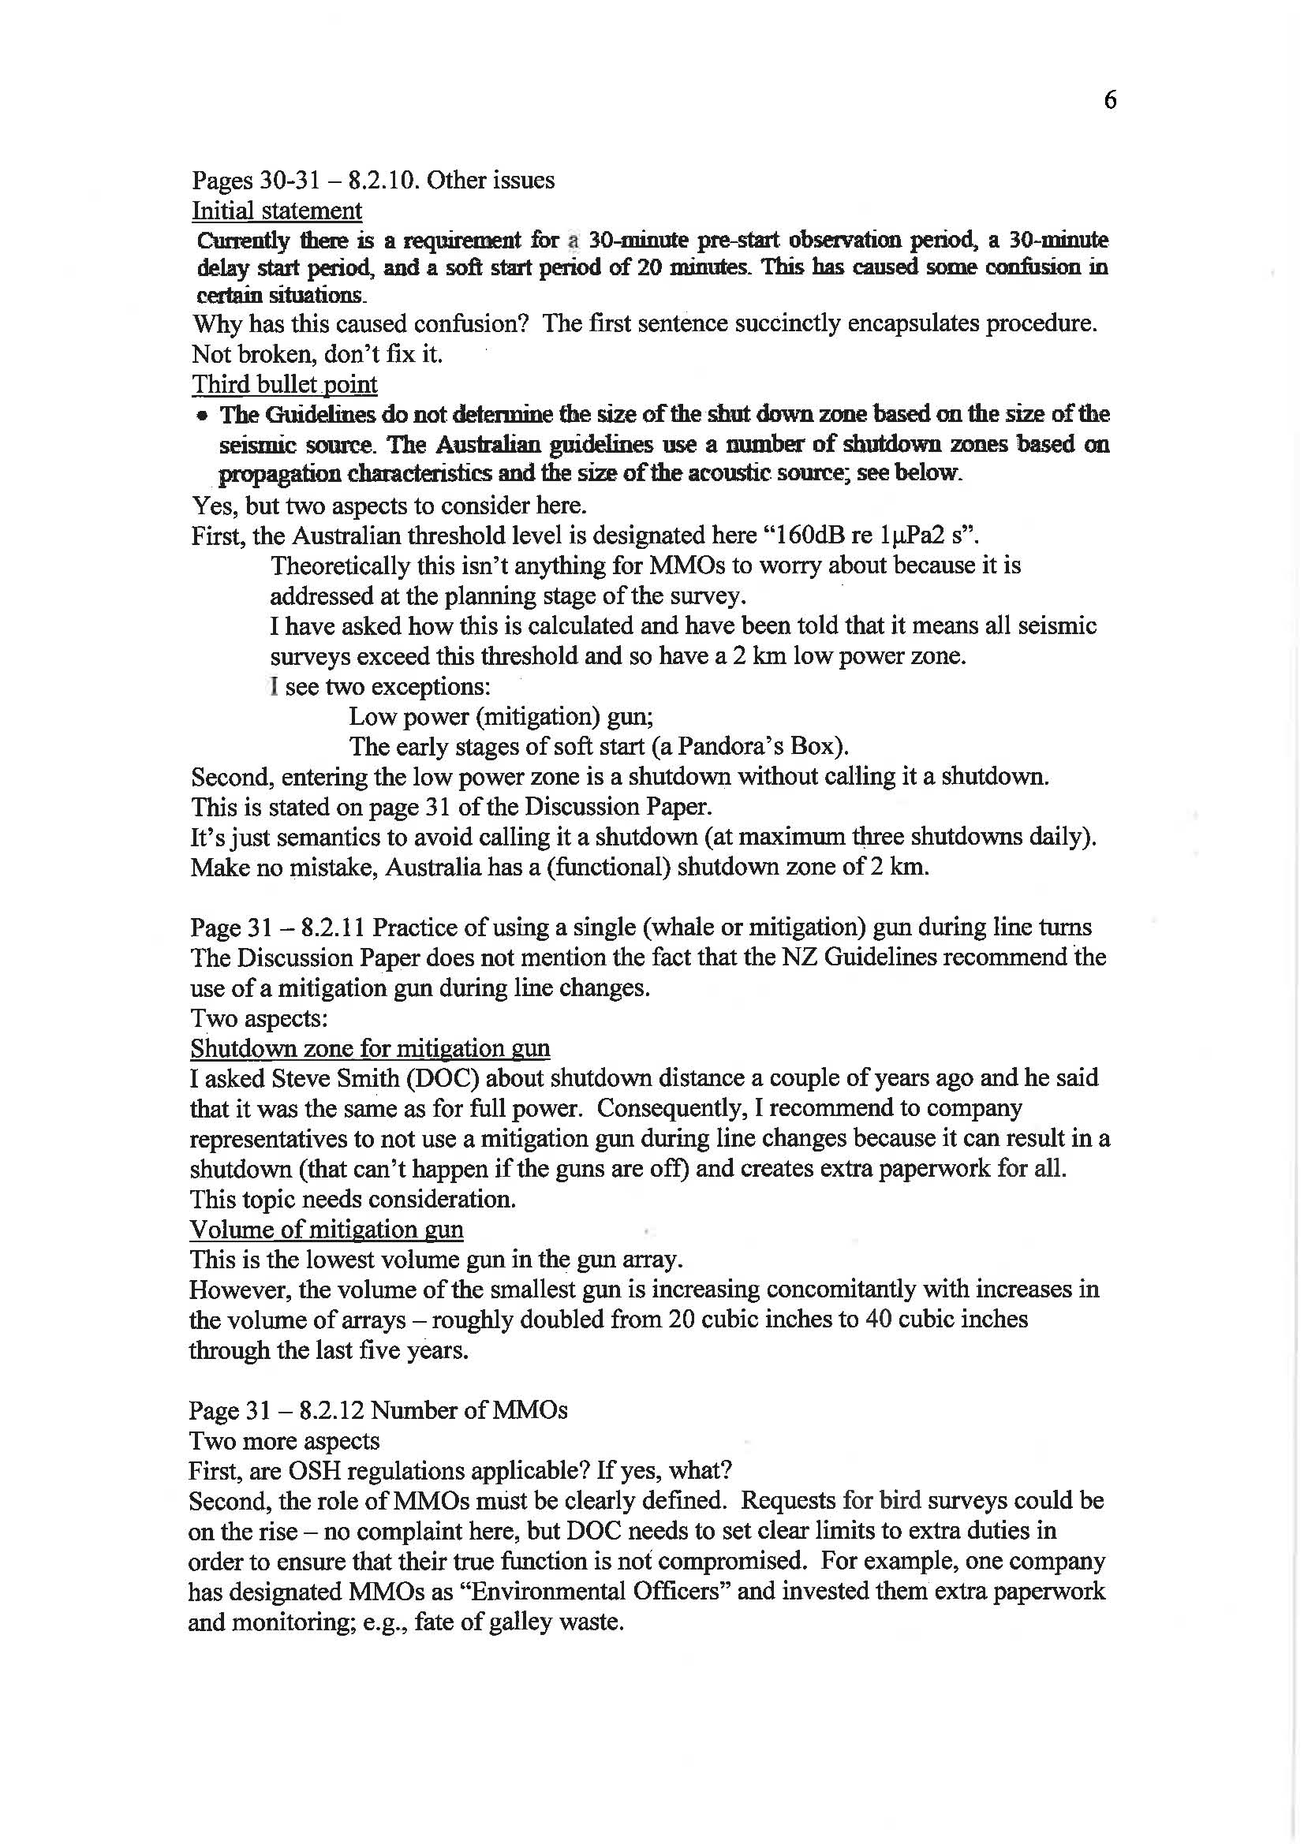

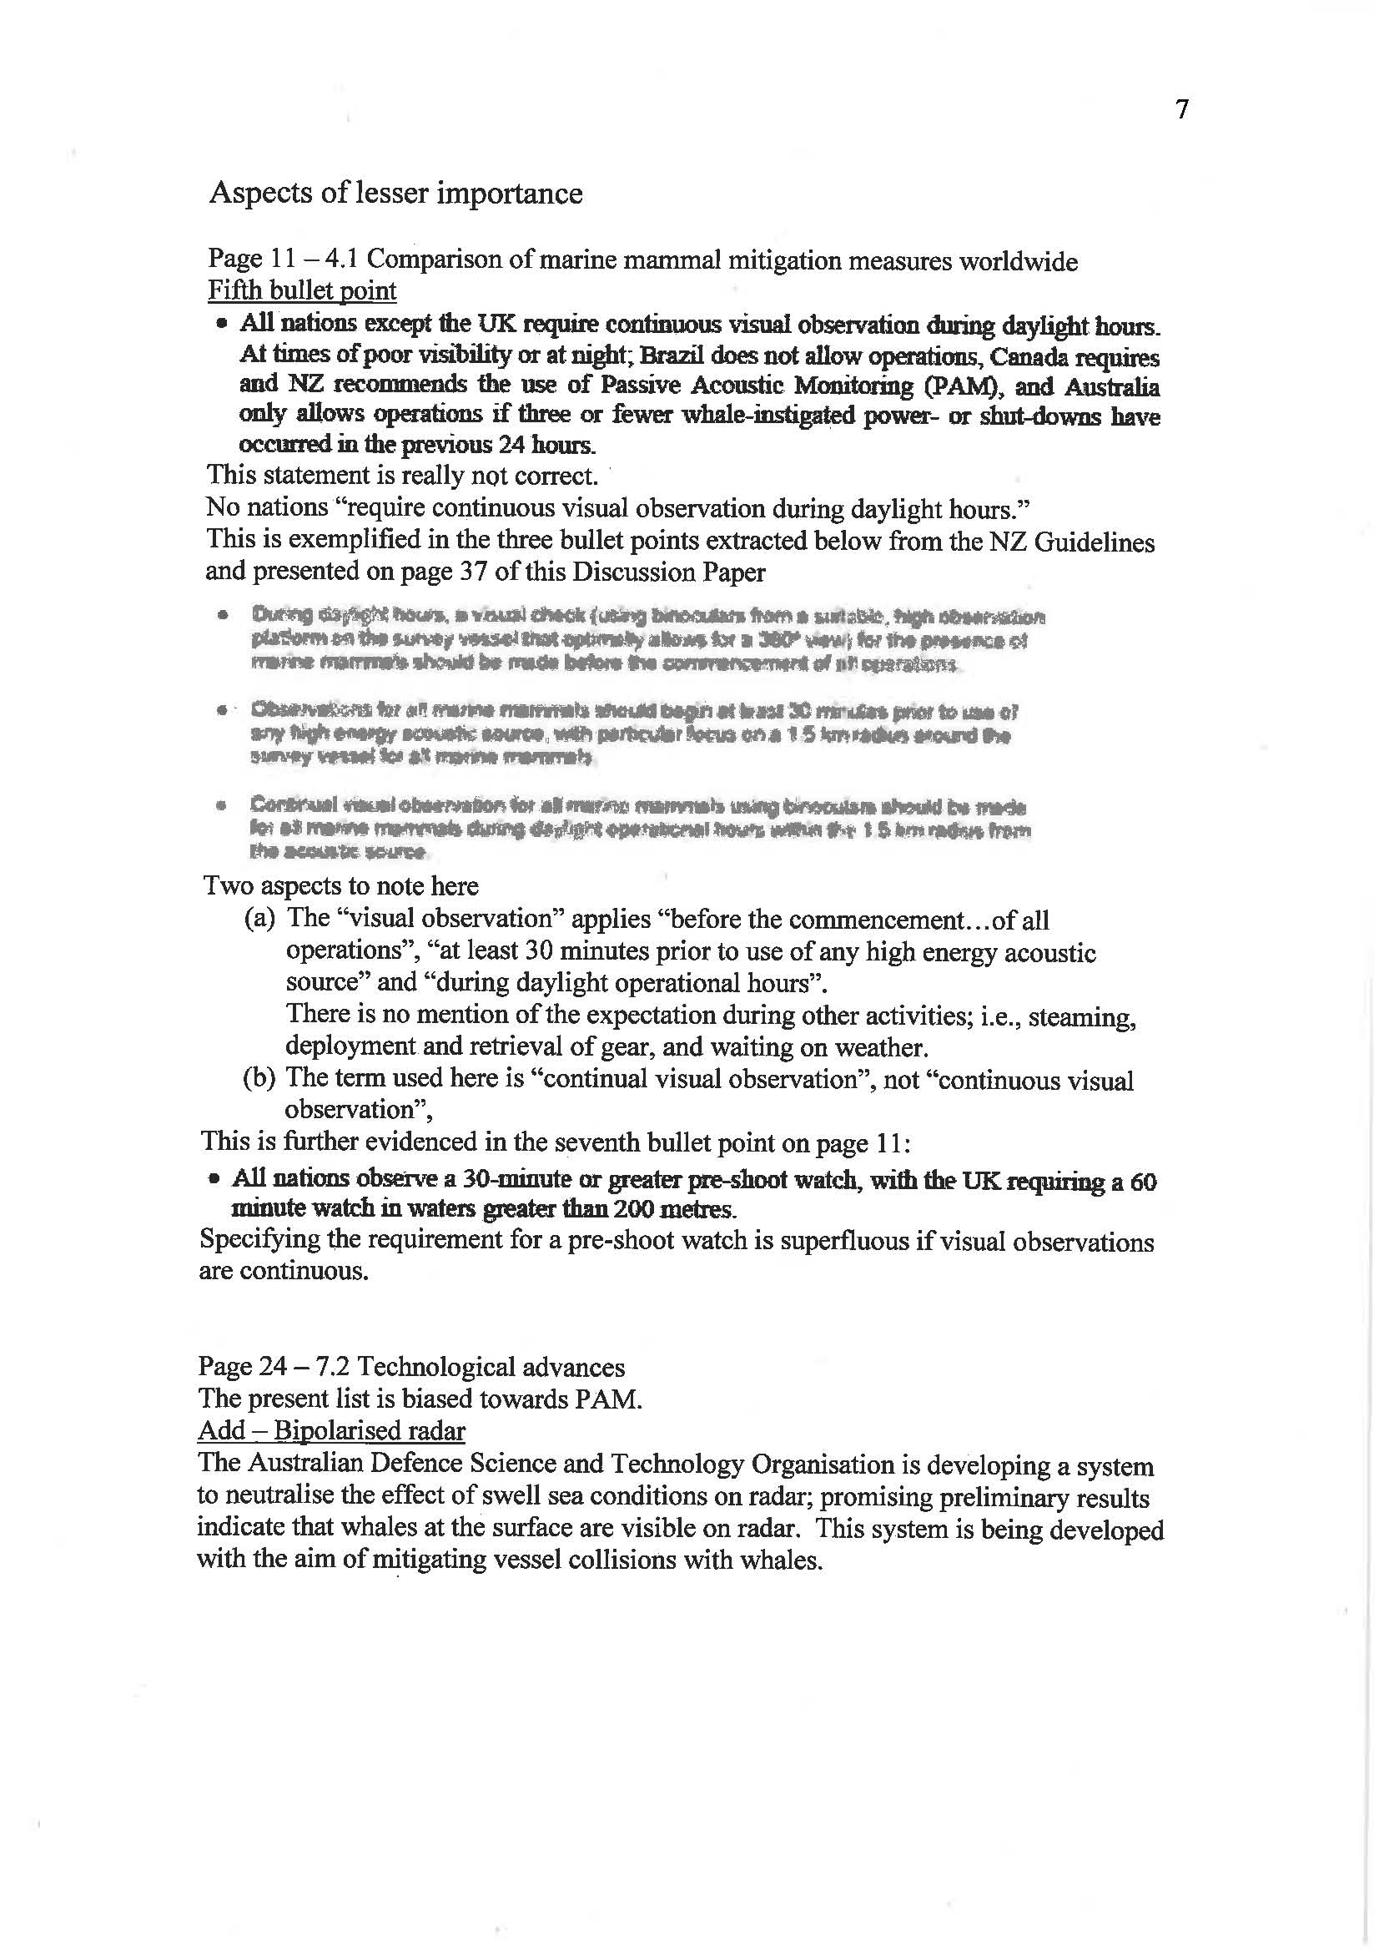

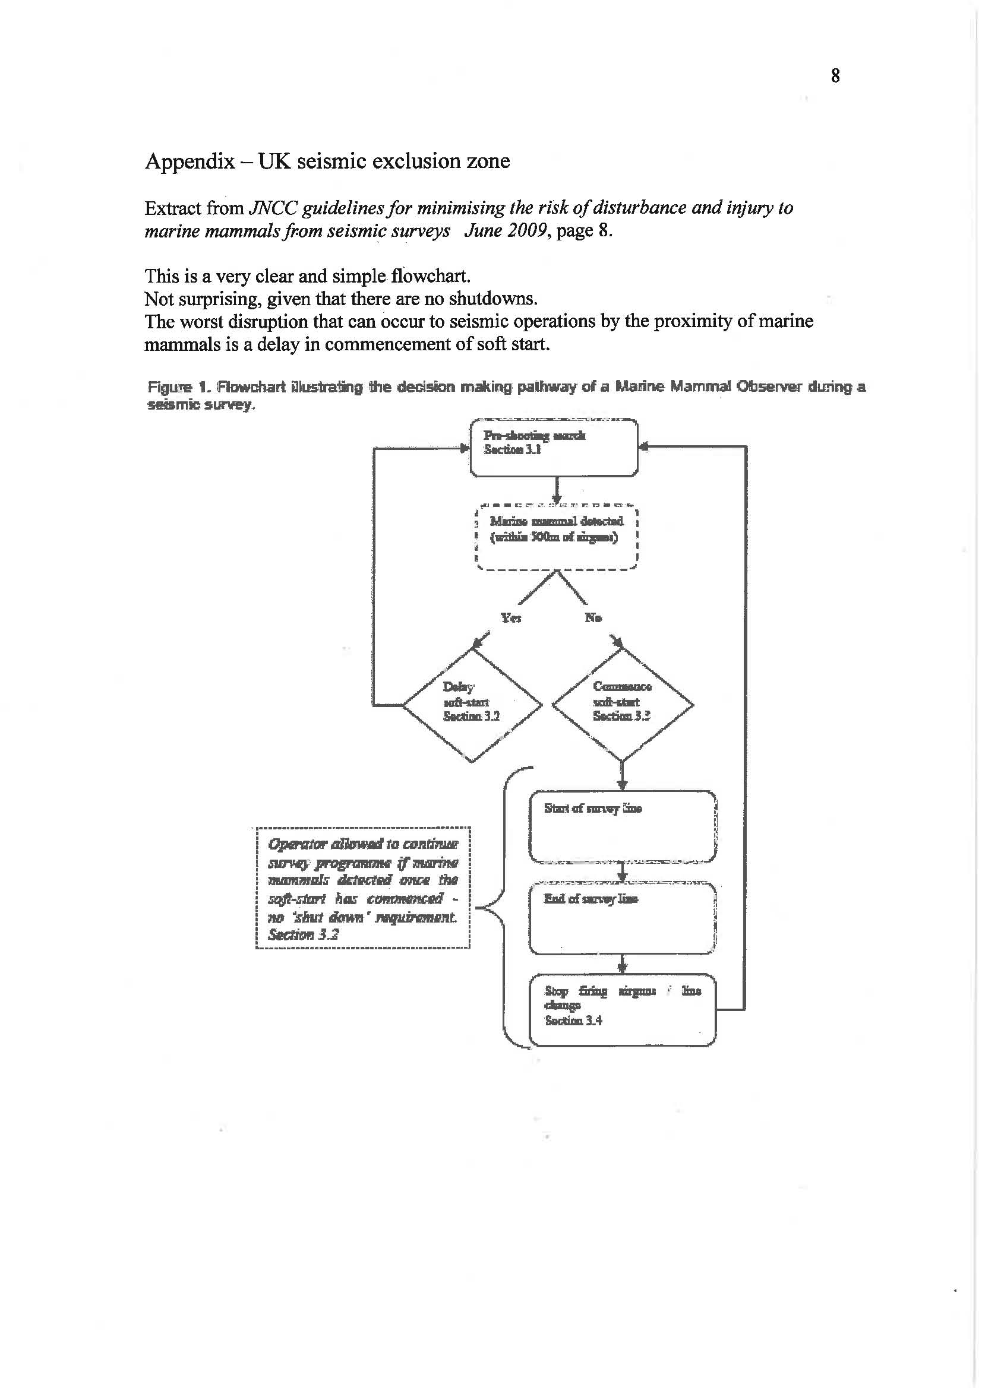
Appendix 2
Submission – Bill Armstrong (Todd Energy)

From: Bill Armstrong [mailto:barmstrong@toddenergy.co.nz]
Sent: Thursday, 27 May 2010 11:49 AM
To: dave@blueplanetmarine.com
Cc: John Pfahlert
Subject: FW: Review of DOC Seismic Guidelines

Dave, comments from our technical people at Todd.

Regards, Bill.
________________________________________
From: Mark Blood
Sent: Thursday, 27 May 2010 11:52 a.m.
To: Bill Armstrong; Rick Henderson
Cc: Neville Smith; Chris Hall; Hilary Dussing
Subject: RE: Review of DOC Seismic Guidelines

Bill – having read through the BPM document and discussed with Rick we agree that the following should be communicated to BPM with respect to the document contents and present guidelines.
Legislation: current guide lines work because operators can pick and choose the bits they want to comply with and what to ignore. This is not satisfactory and puts the NZ industry at odds with its international peers. Given there will at some point be pressure on the authorities to legislate, NZ operators should support a move to self regulation. Self regulation of the present guidelines looks to be generally ok with some exclusions (e.g. PAM). Contrary to Rick’s, earlier view we agree legislation of some form will place us and the NZ industry in the majority with all other countries who legislate, It will promote consistency among operators and improve efficiency of operations. For example, if a dedicated MMO is required as mandatory then there would be sharing of this individuals mobilsation costs + more efficient handover from one operator to another during change of survey without the need for a subsequent operator having to mobilise or remove an individual outside of vessel crew change. Additionally, the move to legislate would be looked on favorably by NGO’s such as Greenpeace. The message is we (i.e. PEPANZ), should be seen to be proactive in securing enforcement of acceptable guide lines rather than having to be reactive down the road when they may be more onerous. Legislating for the current guide lines will be commercially neutral to Todd as we currently comply with them.
2. Pinnopeds: We do not support the inclusion of Pinnopeds in the guide lines. As the draft document mentions they are small and difficult to see and in general can be very numerous. Let NGO’s focus their efforts on banning the employment of pinnopeds at water parks and the like before forcing their ideals on the seismic industry.
3. Referencing 2. and given the lack of research/repeatability of behavioral findings, we believe that outside of marine reserves the guidelines should be applicable to cetaceans only (whales, dolphins and porpoises) and not marine mammals in general. This is what the guidelines were originally intended for. Special cases can of course be made for endangered species where seismic activity would stray in to breeding/feeding/migration areas which have not been designated marine sanctuary’s.
4. PAM: Use of this monitoring equipment is controversial as well as costly. There is a case for it to be used in marine parks but no hard evidence to suggest that its use in general waters is beneficial or even reliable. It should remain an option only in its use in open waters until further research demonstrates its benefits. Rick’s suggestion of installing PAM at the Maari platform (subject to JV support) is a good one and will help further evaluation of this monitoring system in the Taranaki before any legislation for its mandatory deployment on seismic vessels gains traction. We should propose this to BPM.
5. MMO’s. We employed 1 qualified MMO who was assisted by trained crew members. This is sufficient for surveys of the size currently shot in NZ waters. Large IOC’s will normally employ 2, 3 or 4 MMO’s depending on the size/duration of their surveys. We do not require more than 1 qualified MMO.
6. Birds The industry should not assume that marine mammals cetaceans are the only animals that require monitoring. For our GSB survey we were requested by Ngai Tahu to monitor mutton birds. The concern was the seismic activity would drive the fish from the birds normal feeding grounds. No thought or consideration had been given to this by the operator beforehand. The industry should be aware that local stakeholders may have specific interests outside of the general whale watching theme and be prepared to accommodate this in the interests of good relations. We are surprised that BPM don’t even give this a mention.

Regards
Mark

Mark Blood
Exploration Manager
Todd Petroleum Mining Ltd
________________________________________
From: Chris Hall
Sent: Tuesday, 25 May 2010 6:12 p.m.
To: Hilary Dussing; Mark Blood; Neville Smith
Subject: FW: Review of DOC Seismic Guidelines

Chaps, for comment direct to Dave Patton please

Kind regards
Chris

From: John Pfahlert [mailto:pepanz@xtra.co.nz]
Sent: Tuesday, 25 May 2010 2:35 p.m.
To: Andrew.Jefferies@omv.com; 'Anthony Joines'; Bev Wisnewski; Bill Armstrong; Brian Satur; bruce.colgan@stos.co.nz; Burton, Neil; Chris McKeown; David Russell; Dennis Washer; DICKEY, Phil ; EATON,Simon; 'Gary Rielly'; Janet Kidd; John Bay; Joines, Anthony; Kathryn Hooper; Keast, Paul STOS-JVP/A3; Kim Beech; Lambert, Amanda; Mac Beggs; Nicholas CAVAYE; Niki McEwan; Oakes, Mike; Patricia Green; Patrick, Dr Mike; Philip.Barron@aretelimited.com; Rachel Devine; Simon Knapman; Simon. Roddy; 'Wayne Gower'; BENNETT, D; Bishop, Greg; Chris Bush; Chris Roberts; Dave Coull; Fay Batchelor; Chris Hall; Kirk, Wayne; Lynette Murray; 'Ron Kelly'
Cc: 'Anderson, John'; 'Allan, Tim'
Subject: Review of DOC Seismic Guidelines

Important: Read This
Attached is the draft report from the consultant retained by DOC and Pepanz to review the 2006 DOC Guidelines for Minimising Acoustic Disturbance to Marine Mammals from Seismic Survey Operations.
Comments on the draft should be sent to Dave Patton at Blue Planet Marine by 15 June. Dave’s email address is dave@blueplanetmarine.com
The document was commissioned to identify issues which needed to be considered when the Department and industry commence a formal review of the guidelines later this year. It doesn’t recommend a particular course of action. Rather it identifies new scientific knowledge that has come to light since 2006, changes to the status of marine mammals since 2006, and best practice from overseas which might usefully be considered when reviewing the NZ guidelines.
The document is intended to be finalised by 30 June and issued as an independently commissioned report to inform the ongoing process of industry/public consultation.
This morning a meeting was held at DOC with scientific researchers, marine mammal observers, industry and NGO’s to discuss the report and seek feedback. The meeting was constructive and identified a range of issues that will need to be considered when the guidelines are reviewed. I will be meeting with DOC during June to discuss the review process and timetable.
Because Pepanz is one of the parties commissioning this report we won’t be making a separate submission. However if companies have any issues they would like to raise with Blue Planet Marine then now is the time to do so. If you don’t do so now there will still be plenty of opportunity to be involved in the process later this year when the DOC consultation document comes out.
(There are some formatting and quality issues with this copy of the draft that will be sorted out when the final is produced later in June. We reduced the files size for ease of emailing.)

Regards

John Pfahlert
Executive Officer
Petroleum Exploration and Production Association
PO Box 5227
Wellington
04 472 1993
www.pepanz.org
Appendix 3
Submission – Carol Sutherland (Marine Mammal Observer)

From: Laura Boren [mailto:lboren@doc.govt.nz]
Sent: Thursday, 10 June 2010 7:25 AM
To: Dave Paton
Cc: John Pfahlert
Subject: FW: Marine Mammal Observer comments on Review of Guidelines
Comments from Carol.
Cheers, Laura

From: carol sutherland [mailto:carol.kupu@hotmail.com]
Sent: Wednesday, 9 June 2010 7:36 p.m.
To: Laura Boren
Subject: Marine Mammal Observer comments on Review of Guidelines
Hi Laura.
Did this on the plane over last week. Was hoping to add more but busy doing a database for a specific project here. Bit of a learning curve about machines that go 'ping'. Anyway attached is my two cents worth. I would like to have made further input but alas...the Humpies are on their way!
Regards
Carol
Attached file:
SUBMISSION ON REVIEW OF GUIDELINES
CAROL SUTHERLAND

This submission is brief due to upcoming commitments at sea.
The areas I wish to comment on are largely limited to data collection and Marine Mammal Observer methodology. I am also restricting comments to visual observations, as although I have received PAM training I do not believe I am qualified enough to be even let loose near a PAM system. Like most things at sea, it takes longer and needs experience.

It is generally agreed that there are limitations to the existing data concerning seismic surveys and how that impacts on marine mammals.

MMOs are in the position to collect data at sea that can contribute to our understanding of marine mammals and in turn assist Industry in planning seismic surveys.
To be effective data collection needs to be standardized and the methods used by MMOs to be as objective as possible. At present, both here and overseas there are many variables in the field, and the existing databases can be cumbersome or deficient in their scope. (Perhaps nobody can agree on the perfect one.)
Whether there is Guidelines or Regulations, Industry and scientists need good data coming in from the coalface. Poor quality data is worse than no data and neither Industry nor Government can rely on it to make management decisions.

The main points I wish to rise are:
Standardisation
Methodology
Quality control

Standardisation
Clarification and definitions on all documents.
There is no clear standard and definitions of what are some of the basic requirements.

What constitutes ‘observing’.
Looking out to sea awaiting sighting cues is different from a scanning process used by bodies such as the navy. Having MMOs casually looking for hours on end without suitable breaks and eye exercises, or lengthy report writing at the back of the bridge and relying on Mates, will present different results than someone trained (and experienced) to look for subs/boats/whales.
Objects in the sea are important to spot before any grief is caused.

There is no clear agreement over what ‘continual’ and ‘observing continuously’ means. Is this constantly looking, or carrying out interrupted observations but on a continuing basis throughout daylight hours, or being on call if the bridge officers sight anything?

Much of MMO data is based on observer effort, thus what constitutes observer effort must be standardized and clearly outlined as to what it means. Is gym time equal to scanning from the flying bridge?
The MMOs are not super heroes with stamina to match, but observer effort must match the recording of effort, whatever is decided as the level of ‘observations’.

To facilitate standardization of data there must be a clear understanding of commonly agreed upon definitions throughout. I would like to see a detailed glossary with Guidelines or Regulations.

Database
Each MMO will have their own approach to data collection, and as individuals this allows creativity but when there is more than one collector then the data, if it is to be used meaningfully, needs to be collected in a more rigid and consistent way.

The point of data input is the database.
At present DoC has reporting requirements on Word doc. This is not unusual among other countries, as both Australia and the UK had paper sheets up until recently, (and still use them on some surveys) but New Zealand is in a position to create their own based upon fields they want, and to improve on existing databases.
In creating a database one can draw on others in terms of fields that might be compatible internationally, especially if there is to be any sort of information sharing in the future, but one should not follow slavishly in the belief that ‘overseas’ systems are somehow more proficient.

New Zealand is unique in that 100s of NZ Fur seals can be encountered on some surveys. This might require a separate, but survey linked entries apart from cetaceans. Partly due to their brief and variable movements close to the vessel, the relationship to the gear rather than array but also due to time constraints on MMOs. Time spent on extensive sighting forms for seals means less time available for observing for whales. The volume of sightings encountered means that the recording has to be concise for this species. Extensive and time consuming forms risk marine mammal presence being missed by MMOs.
(Making MMOs responsible for monitoring garbage disposal, extensive at sea reports and other duties erode the concept of ‘dedicated observer’ and impact on observations. MMOs are not HSE Officers.)

New Zealand is also in the position to introduce digital mapping from the MMOs that use GPS systems at sea. Garmin Mapsource is one easy and widely available system and can produce GIS information. Flat looking but based on nautical charts. Google Earth and other applications should be investigated. How much precision is available as opposed to ‘looks’? Not all MMOs use a GPS but it is a useful tool to those who wish to accurately record cetacean positions, movement and direction by plotting those sightings on electronic charts.

Information gathered by MMOs would still be the property of the company hiring the MMOs, but to have the Industry as a whole having one central body to contribute to, and draw upon, then a standardised database is needed.

Seismic operations are unique in that Industry, through their MMOs can contribute to the understanding of marine mammals on a scale and intensity that is unavailable elsewhere. (Albeit from a vessel producing noise.) Industry, by ultilising their MMOs beyond the role of compliance, can strengthen their participation on issues concerning marine mammals but in order to do so they need credible data sets. Industry can contribute and utilise better databases than existing ones, and I believe it would not be difficult to do.

Important is having a database that is coherent to all, allows quick and easy input, is compatible to most operating systems, and covers the fields that are required.

There are other reporting systems around, such as the AAD database that is available for inputs on line, but for use at sea such systems can be awkward, do not operate properly and have not been field tested. Pretty graphics should not be sent to sea as they slow the ship’s internet systems.
Also, some reflect transit surveys instead of seismic surveys. Where it takes several minutes to enter one of the many pages that cannot even be scrolled and windows that cannot be opened simultaneously, then having an extra MMO for data entry/report writing is one option, but it is not very efficient.
Understood that AAD database is still ‘under construction’.

The JNCC data fields have some helpful aspects and are used extensively worldwide but as a MMO, I believe it is deficient in some areas when it comes to monitoring marine mammal behaviour around seismic vessels. Need objective and accurate whale direction, not based on MMO estimations.

There are databases around that virtually ignore seismic operations or limit it to: ‘On/Off survey’ these should be binned. Any that rely on MMOs to comment on marine mammal movement without multiple sight positions, or use relative plots as opposed to true plots should be subjected to the delete button.
Data at the sighting level should be as detailed as feasibly possible (without expanding disproportionally on the time aspect) as that is the base data from which all is derived.
Information must be salient to the seismic Industry and other industries that might operate sound sources in the marine environment. (Pile driving, explosives, construction, and low to high-frequency SONAR, multibeam etc . That is if the Guidelines cover sources other than seismic airgun arrays.)

Excel and Access are easier to construct, are compatible for the majority of users and can be easily accessed. Having a layout that is MMO friendly and quick to use in the field will assist in the collection of good data and cut down on the amount of time a MMO is dealing with data inputs and collating information. Whatever the database may be, the fields and practicality of operation should override ‘professional look’ and pretty pictures.

The MMOs are the ones entering the data so having MMOs contribute to any database design will help in constructing a well-organized and proficient system that can be used at sea in the seismic industry. Also, those receiving the data must be clear on the areas they wish to be covered and outline clearly both the definitions and methodology.

I would like to see DoC and Industry agree upon a database that is an improvement on the existing ones. DoC, Industry and MMOs can construct a database that is acceptable to all as well as being standardised and stringent enough to be used for scientific purposes.

Summarising database:
Ease of use
Standardised fields
Clear definitions of fields
Compatitable
Acceptable to Industry, DoC and MMOs
Stringent enough for scientific use.
Possible GIS component
Improve on existing

Methodology
There are two main functions the MMO carries out.
The compliance aspect, and the recording of operations that a pertinent to marine mammals.

Industry hires MMOs to advise and help the vessel comply with the standards set by the relevant authorities.
If an exclusion zone operates then the MMO needs to accurately measure the distance the animal is from the array and inform the vessel accordingly. The survey is a major undertaking and to cease acquisition, the reasons for it should be demonstrable and accurate. In turn, the call should be made accurately to protect marine mammals from any potential harm.
To be quite blunt, any MMO that relies on distance estimations by eyeballing them should be hauled off on the next helicopter. Regardless of BSC, MSC or PhD.

The skills a MMO needs to determine distances at sea, movement and speed of cetaceans (thus important indicators of behaviour) are not taught in any detail, if at all in the courses that exist.
JNCC even outlines incorrect methods in Direction of travel of animals in their MMO Instructions.
A basic understanding of navigation and ship’s operations is as valuable as an understanding of whale biology. Get cetacean speed and direction wrong, then behaviour records will be wrong. It isn’t ‘sexy’ as a tail fluke photo but it is vital.
A Japanese or Norwegian whaler possibly has skills that would be quite transferable.

It is embarrassing to hear stories from Masters and Mates stories of MMOs who have regarded the vessel as a stationary object and are guessing distances. The resulting data is highly erroneous and gives a false picture of the cetacean and ship relationship. That in turn wastes the time of both the Industry and the wider scientific community and can lead to incorrect analysis of that data.
There will always be bridge officers that might resent the presence of a whale spotter, and question their competency, but such errors that have been witnessed can be overcome by training and adherence to methodology that is transparent and accountable.

If Industry and DoC want good data then the possibility of reviewing the methods used by MMOs would be a good measure as to quality.
Companies can differ in their regard for MMOs, and those that have not carried MMOs can choose to select the cheap, blind and the incompetent if they are required to carry a MMO.
That brings the whole Oil and Gas Industry into disrepute and those MMOs bring the profession of MMOs down to the level of ‘whale huggers on a holiday’. (A bridge description of two MMOs in Australia.)
Making mandatory the requirement to carry MMOs does not guarantee quality.

The data collected is as only good as the people who collect it. No one MMO is perfect and there will be differences, as whale spotting to some extent is an art, but good standardised methods inject large doses of objectivity.
MMOs should be regarded as data collectors whose methods are in need of peer review.

Summarising methodology:
Distance measurements to be demonstrable.
Use proper tracking techniques
MMOs methodology to be clearly outlined

Quality control
Training
Requiring MMOs to have the appropriate training should be investigated.
There are MMO training programs that do exist in other countries but they tend to be one or two days and are JNCC focused. It would be preferable to have a quality one for Australasia.

New Zealand can lead the way in terms of quality and methodology.
It is not only good for scientific data but Industry can take pride that it uses MMOs that can be relied upon, and are leading internationally. Also, it would be a benchmark Industry can use when selecting MMOs.
Companies rely on MMO suppliers (contractors) but although it is via contractors, the oil and gas company can be seriously affected if there is an issue of concern with whales. Reducing the risk is having MMOs trained to the highest standards. I believe professionally there is little room in the long term for ‘whale huggers on a holiday’ or ‘ticking the green box’.
The situation of a serious incident might be ‘unlikely’ but there is the severity of consequences to consider. Also, if a MMO cannot have their methods stand up to scrutiny then that in turn will reflect upon the Industry. Better training will help in lifting quality and reduce the ‘unlikely’.

One area that can be drawn on as an example of handling many Observers and relying on standardised methods and reporting for management purposes is Fisheries Observers and Sea bird Observers. However, training and quality control differs internationally.
NZ MFish Observers cannot be confused with EU Fisheries Observers. The former are trained in methodology and collect standardised data, the later untrained graduates who are part of a group that has been tainted with accusations of corruption and with data too deficient for scientific uses.
That is not to say that all EU Observers are incompetent, but training lifts standards across the board.

MMO training is not onerous and professional MMOs both in Australasia and elsewhere would welcome quality training as a way to improve standards. If Fins and Flap can do it, so can the Flukes.

Accreditation
The New Zealand oil and gas exploration Industry does not deploy large numbers of ships, thus large numbers of MMOs are not needed.
Industry relies on MMOs available from their MMO supplier. Industry makes the choice of MMO. There is no certification by parties such as DoC, only the extremely basic JNCC.
Industry is paying for MMO services and MMOs are answerable to the company.

However, consider a hypothetical situation where an incident such as a stranding occurs in an area where seismic operations have taken place. MMOs have been deployed and there have been no sightings in the vicinity of the vessel, but without some sort of accreditation from bodies such as DoC there is the risk that MMOs could be regarded as ‘oil lackeys’ with little credibility by those wishing to make such connections even if they have been supplied by a contractor. The company can ill afford such accusations in the public sphere.
If MMOs have accreditation from DoC, it lifts the Industry's MMOs up in the public sphere and lessens the likelihood of such accusations.

With an accreditation system, DoC can assess the qualifications and methods deployed to ensure that the information received from the survey has been collected using best data collection practices. A similar accreditation system to that operated by JNCC, but preferably one of better quality.
Accreditation is interrelated with training in methods and standardisation of data.

For MMOs having, a system that is standardised with agreed upon methods improves MMOs as a professional group, and although problems have been outlined, there are MMOs out there that do regard themselves as professionals.

The effectiveness of specific mitigation measures depend on how the measures are implemented.
The Guidelines/Regulations are deployed by MMOs at the coalface. That point of contact needs to have ‘best practices’ at its core.

I would like DoC and Industry, as part of the review of the Guidelines, to review the database and the way data is collected.

GUIDE TO USING MARINE MAMMAL RECORDING FORMS
MMO Instructions JNCC 2007
www.jncc.gov.uk

DEWHA Cetacean Sighting Application
http://data.aad.gov.au/aadc/ammc/

GARMIN Mapsource
www.garmin.com
Appendix 4
Submission – Liz Slooten (University of Otago)

From: Laura Boren [mailto:lboren@doc.govt.nz]
Sent: Wednesday, 16 June 2010 10:55 AM
To: Dave Paton
Cc: John Pfahlert
Subject: FW: Seismic guidelines
Sorry – missed sending this one on last night.

From: Laura Allum
Sent: Tuesday, 15 June 2010 4:33 p.m.
To: Ian Angus; Laura Boren
Subject: FW: Seismic guidelines
Just passing this on, I'll assume you know what this relates to.

From: Liz Slooten [mailto:liz.slooten@stonebow.otago.ac.nz]
Sent: Tue 15/06/2010 1:54 PM
To: Laura Allum
Subject: Seismic guidelines
Dear Laura,
Attached my submission on the seismic guidelines.
Liz
--
____________
Dr Liz Slooten
Associate Professor
Department of Zoology
University of Otago

Attached file:
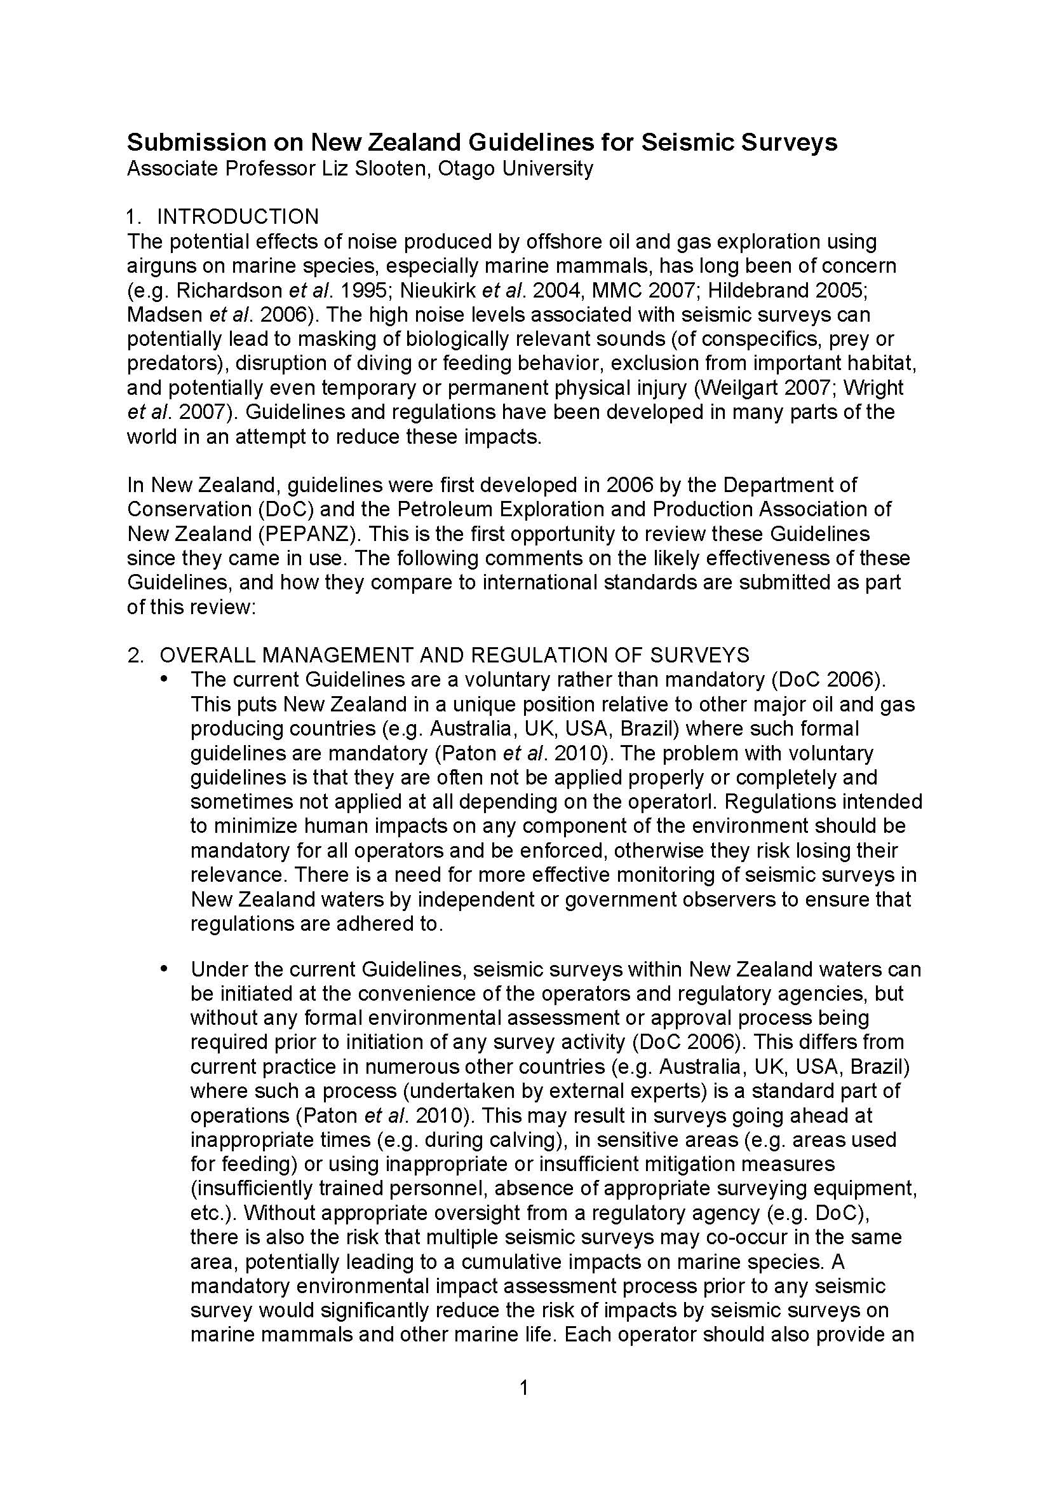

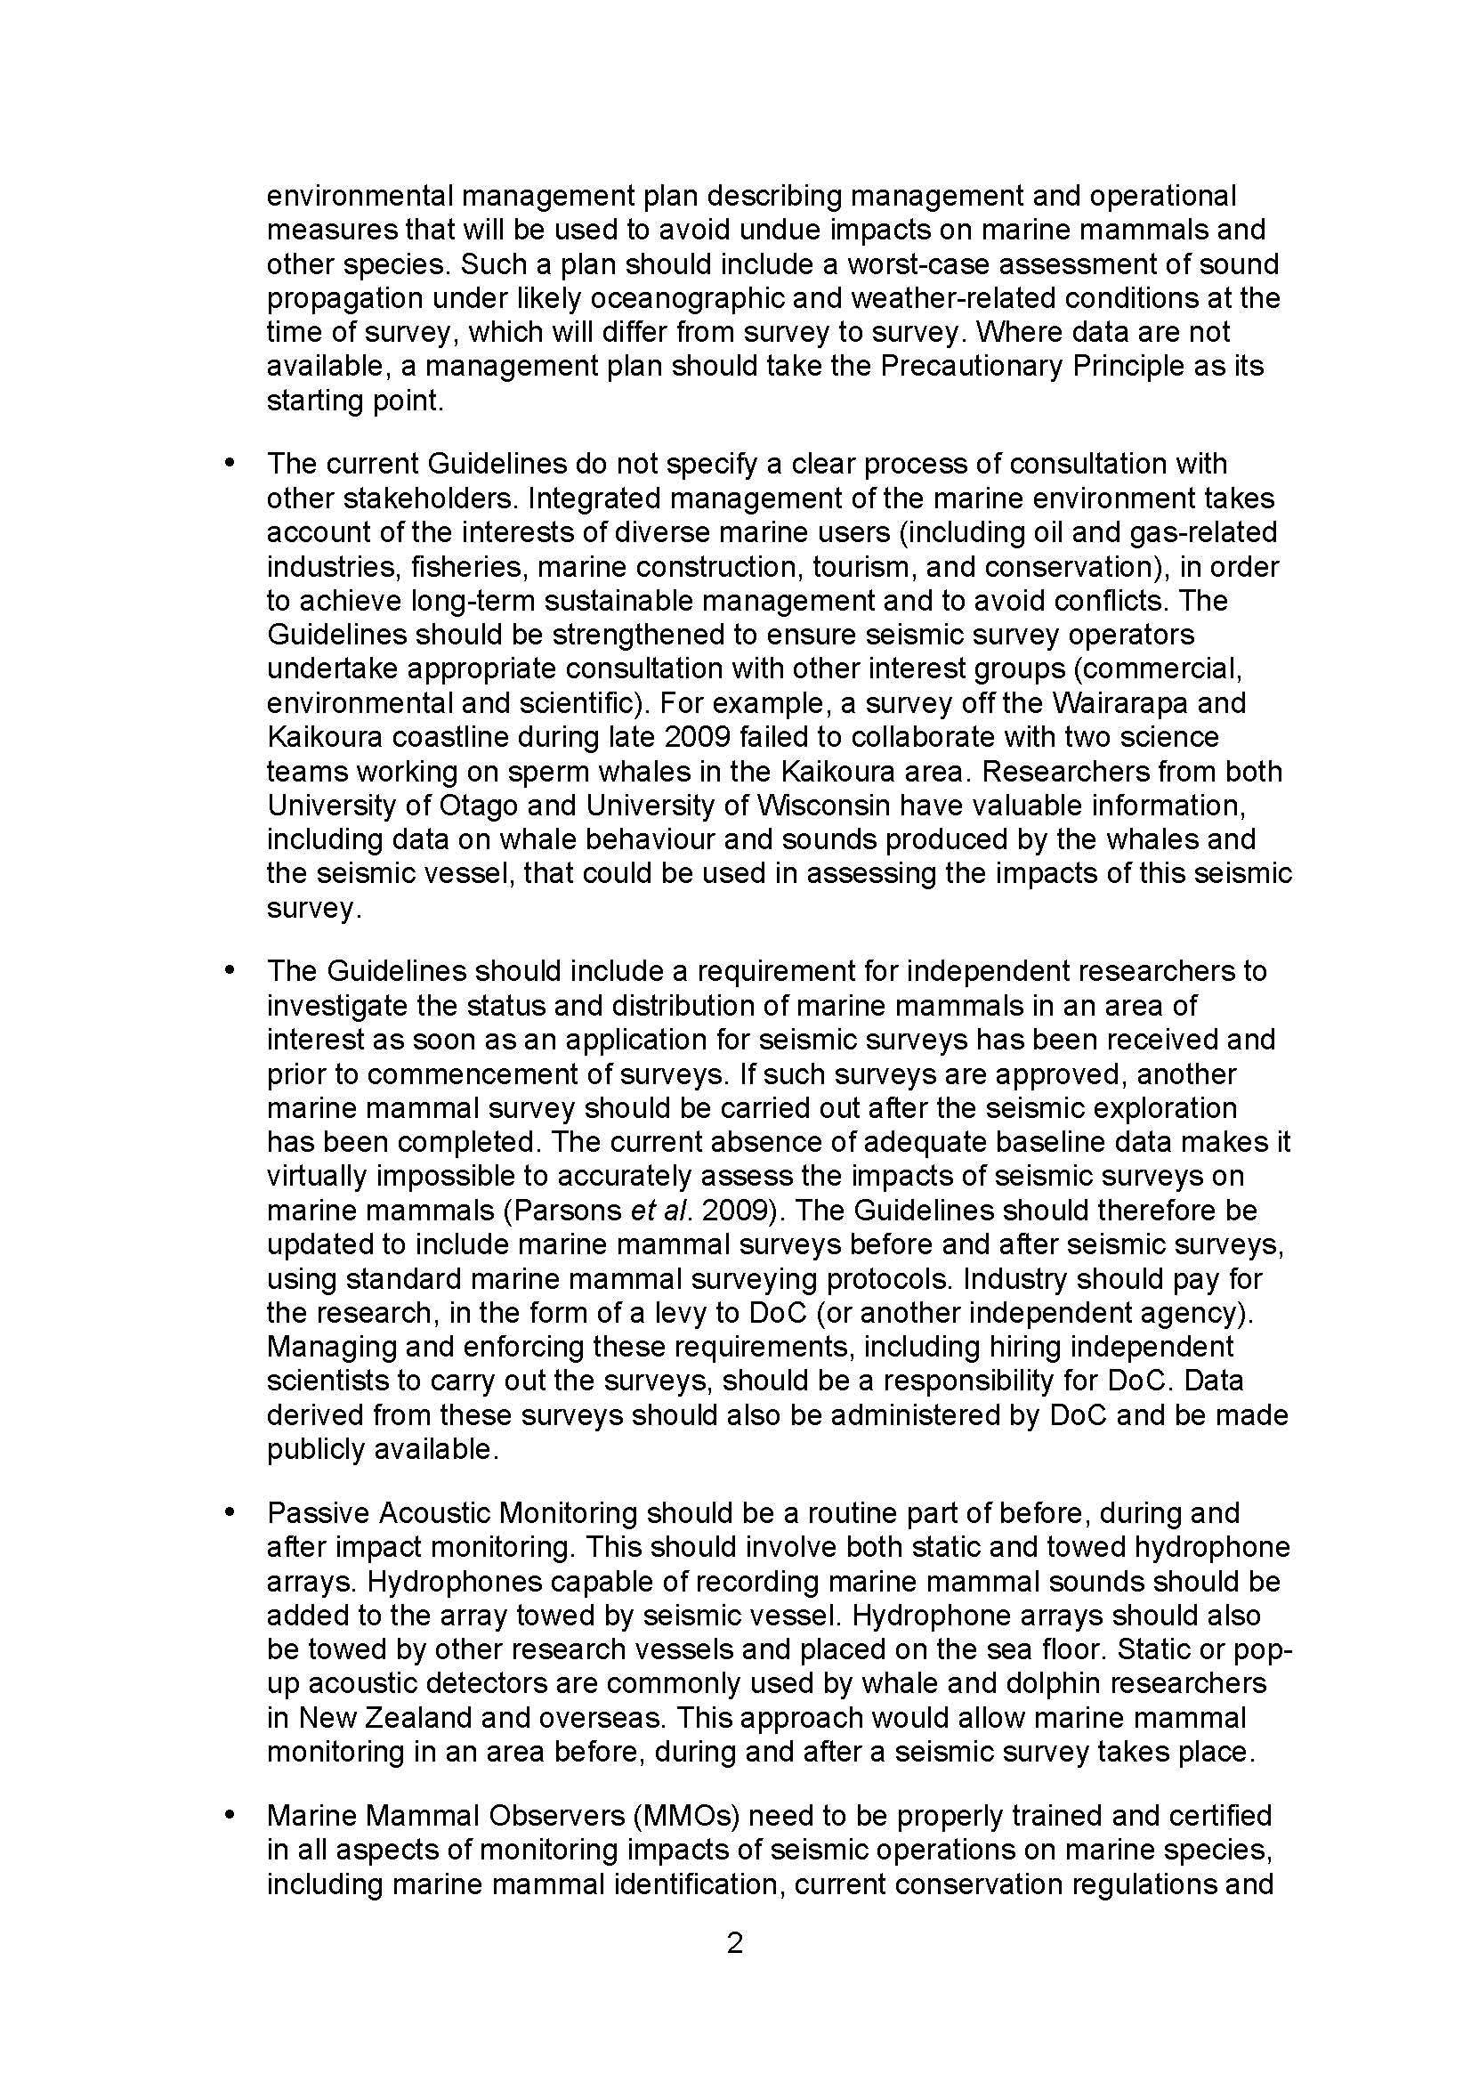

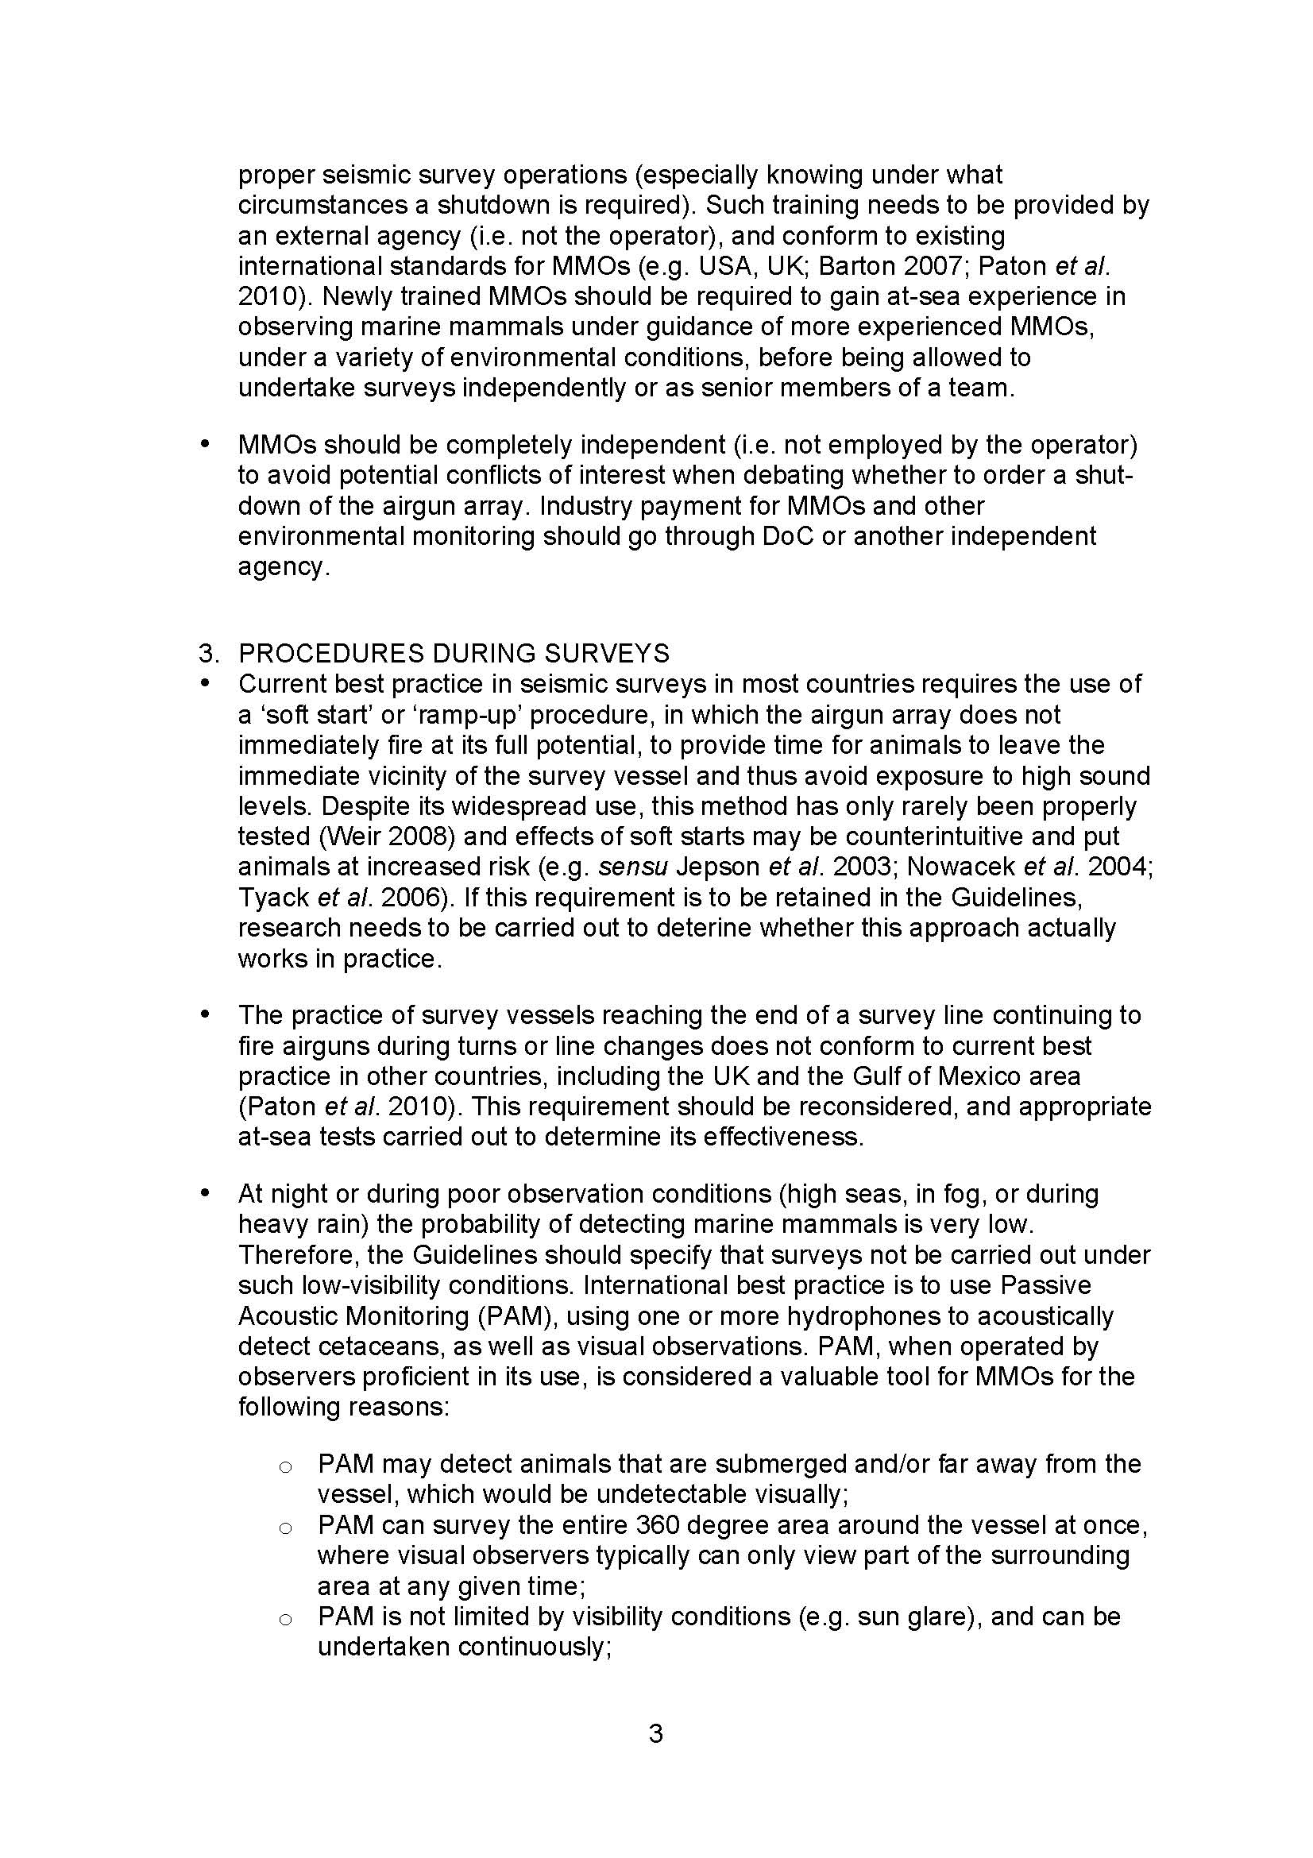

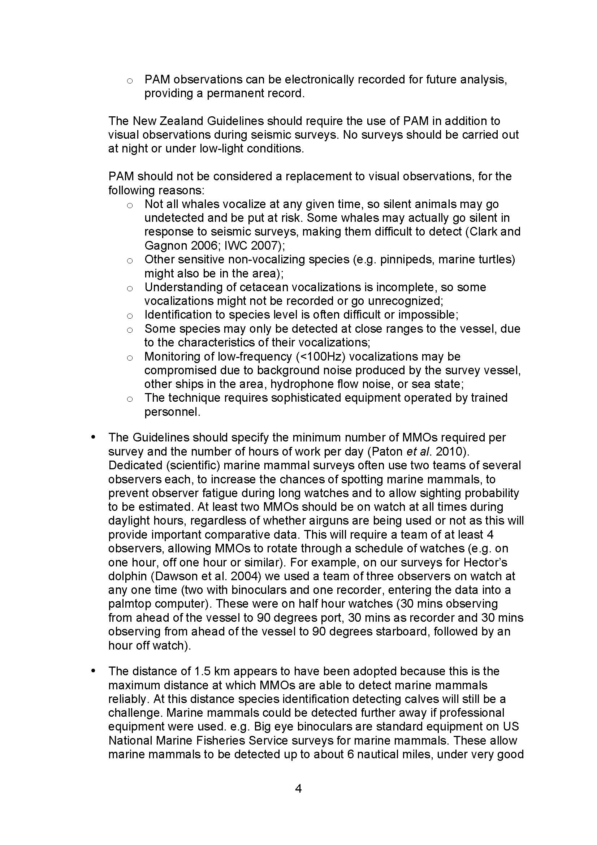

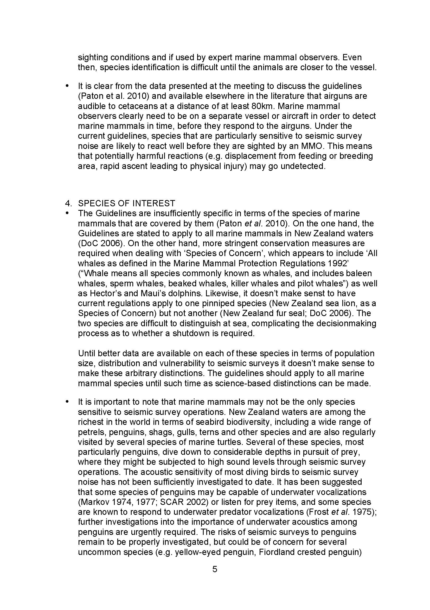

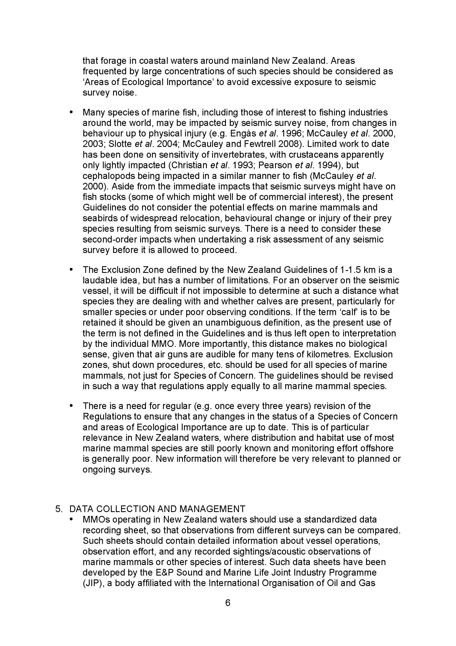

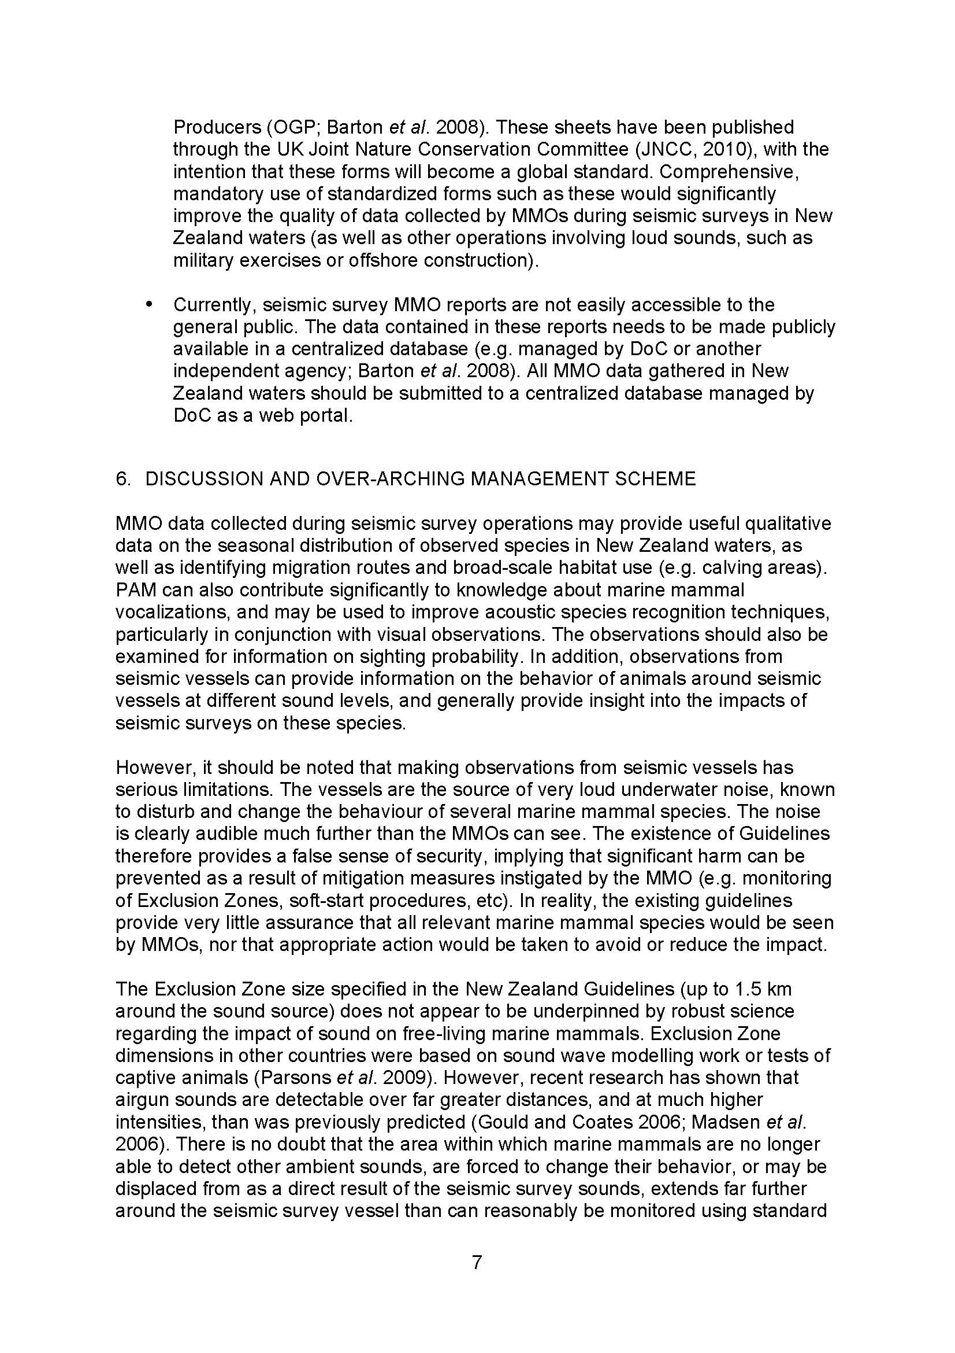

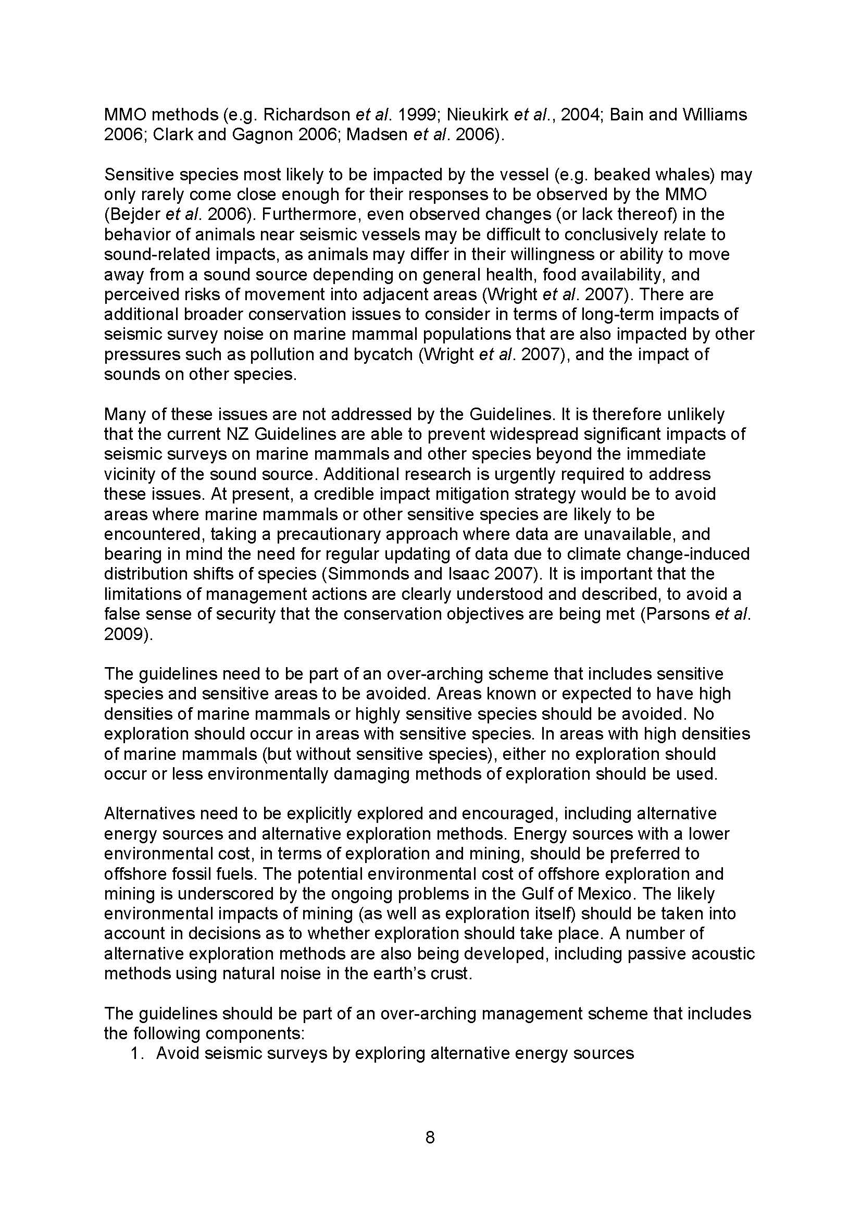

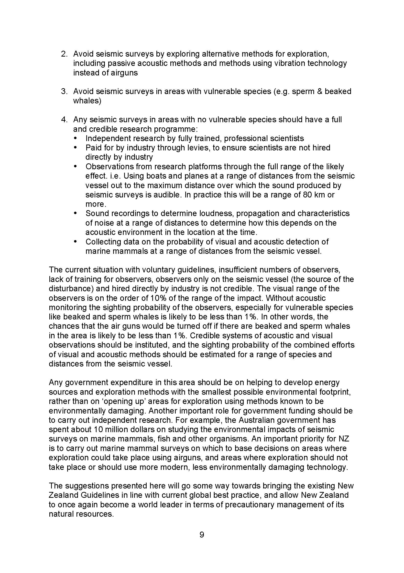

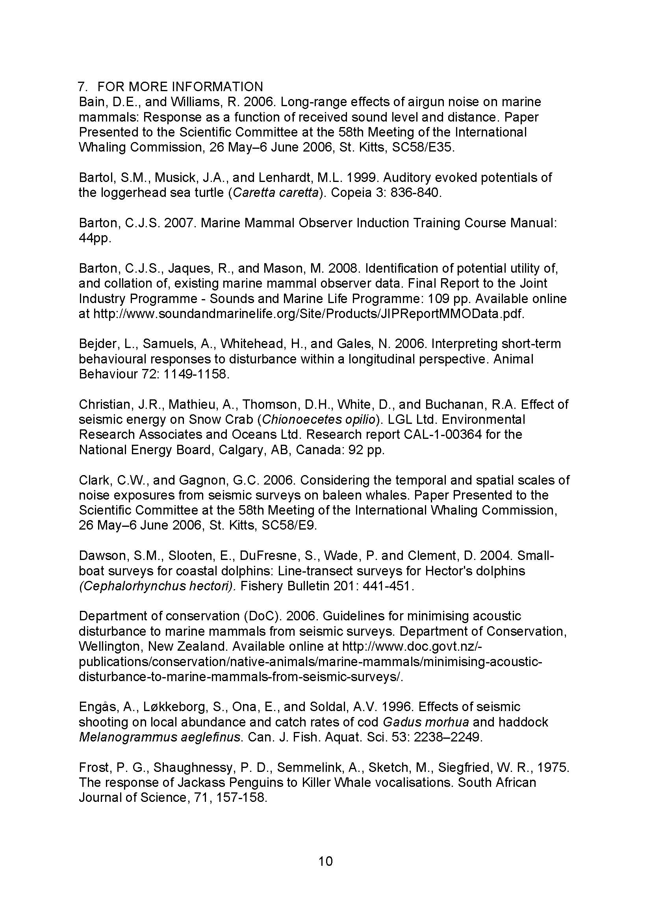

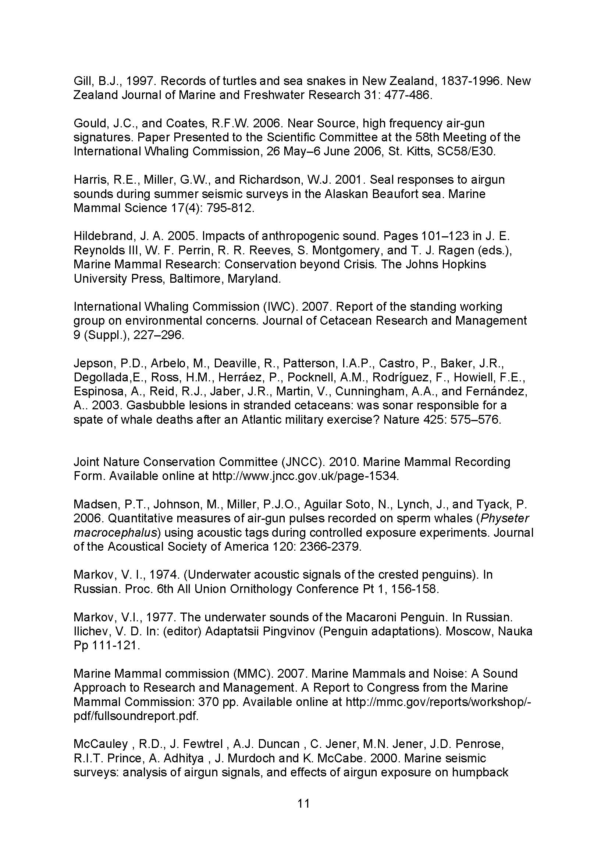

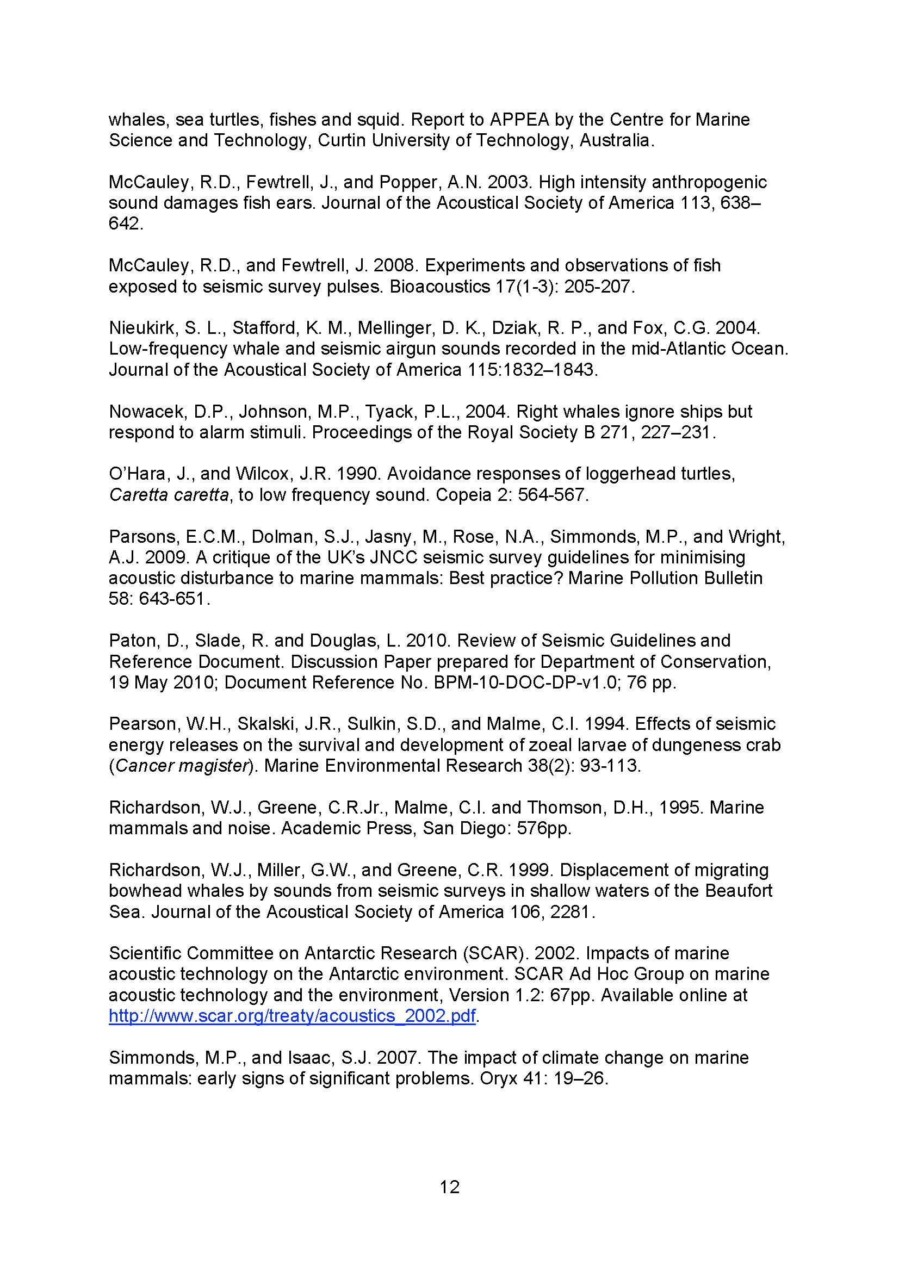

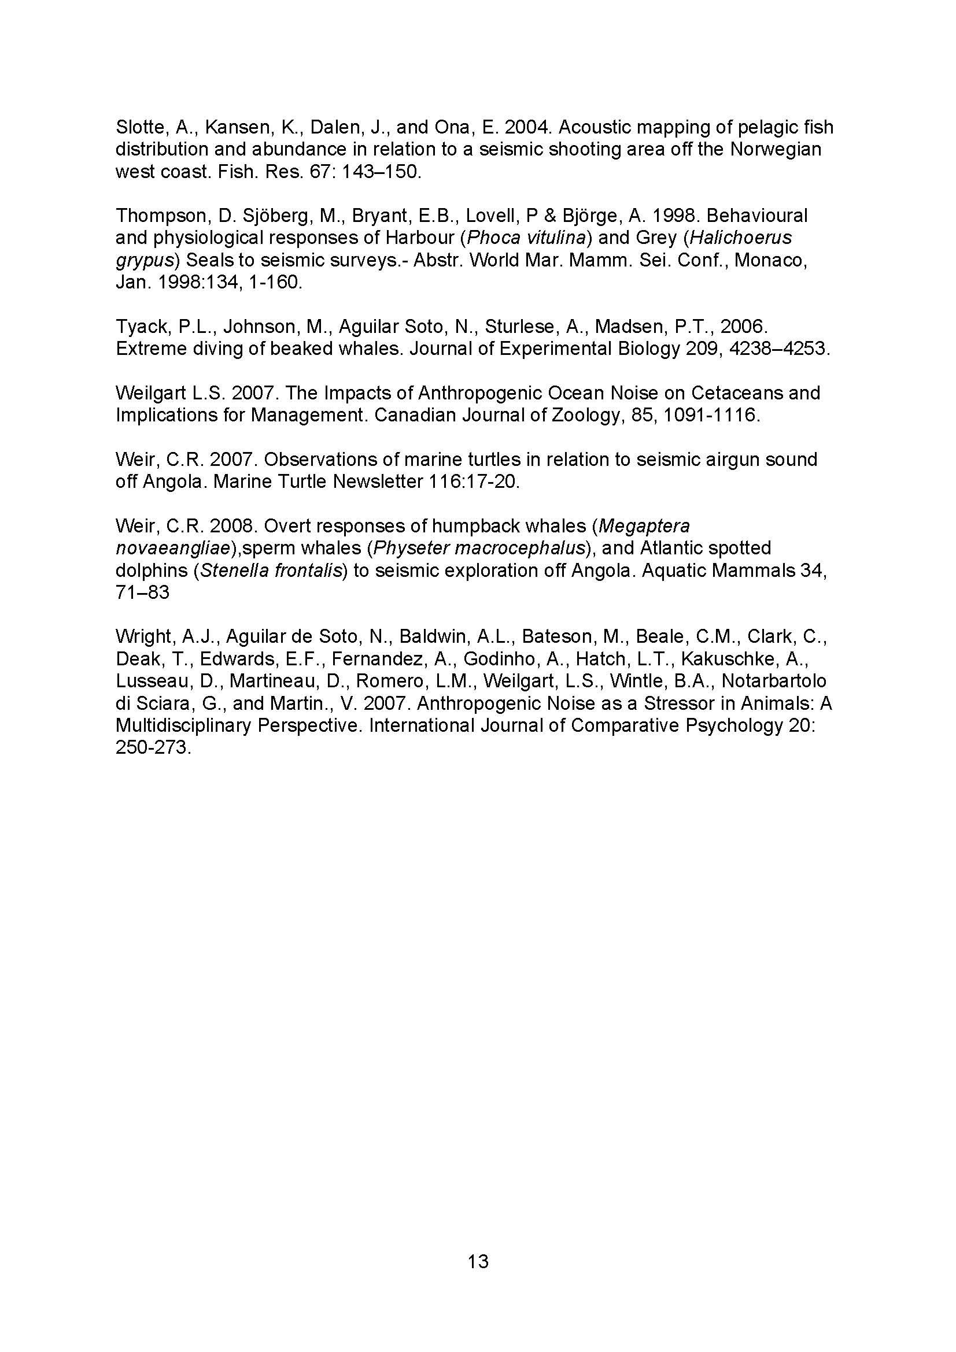

Appendix 5
Submission – Steven Benjamins (University of Otago)

From: Laura Boren [mailto:lboren@doc.govt.nz]
Sent: Tuesday, 15 June 2010 8:31 AM
To: Dave Paton; John Pfahlert
Subject: FW: Submission on NZ seismic survey guidelines
FYI

From: Steven Benjamins [mailto:steven.benjamins@otago.ac.nz]
Sent: Tuesday, 15 June 2010 9:58 a.m.
To: Laura Boren
Subject: Submission on NZ seismic survey guidelines
Hello Dr. Boren,
My name is Steven Benjamins. I am a marine biologist working in the Department of Zoology at the University of Otago in Dunedin, and would hereby like to submit my comments on the current New Zealand Guidelines for Minimising Acoustic Disturbance to Marine Mammals from Seismic Survey Operations, as part of the ongoing review process. Please advise if you have any difficulties accessing this file. I hope you will find my comments helpful, and look forward to hearing from you if any additional input is required.
Kind regards,
Steven Benjamins
Dr. Steven Benjamins
Department of Zoology
University of Otago
Attached file:
A review of existing New Zealand Guidelines for minimising acoustic disturbance to marine mammals from seismic survey operations
Dr. Steven Benjamins
Department of Zoology
University of Otago
340 Great King Street
Dunedin
New Zealand
Tel.: +64-(0)3-4795456
Email: steven.benjamins@otago.ac.nz

- INTRODUCTION
Offshore oil and gas exploration is typically conducted through targeted seismic surveys, where high intensity sounds are produced by arrays of vessel-towed airguns to determine the characteristics of geological deposits below the seabed surface (Hildebrand 2005; Madsen et al. 2006). The acoustic output of such surveys can be considerable, and the potential effects of such high pulsed sound levels on marine species, especially marine mammals, has long been of concern (e.g. Richardson et al. 1995; Nieukirk et al. 2004; MMC 2007). The high noise levels associated with seismic surveys can potentially lead to masking of biologically relevant sounds (of conspecifics, prey or predators), disruption of diving or feeding behaviour, exclusion from important habitat, and potentially even temporary or permanent physical injury (Weilgart 2007; Wright et al. 2007). Accordingly, guidelines and regulations have been developed in many parts of the world in an attempt to minimize these impacts.
In New Zealand, guidelines were first developed in 2006 through a collaborative process between the Department of Conservation (DoC) and the Petroleum Exploration and Production Association of New Zealand (PEPANZ), in a document titled ‘Guidelines for Minimising Acoustic Disturbance to Marine Mammals from Seismic Survey Operations‘ (here referred to as “the Guidelines”). The current process represents the first opportunity to review these Guidelines since they came in use. The present review considered the probable efficacy of these Guidelines, and how they compare to international standards on a number of issues. The main results of this process are summarised below:
- OVERALL MANAGEMENT AND REGULATION OF SURVEYS
- The current Guidelines are voluntary rather than mandatory (DoC 2006). This puts New Zealand in a unique position relative to other major oil and gas producing countries (e.g. Australia, UK, USA, Brazil) where such formal guidelines are mandatory (Paton et al. 2010). There is a risk that voluntary or recommended guidelines may be applied improperly, incompletely or not at all by different companies engaged in seismic survey (here referred to as “operators”), leading to a less effective regulatory regimen overall. Regulations intended to minimize anthropogenic impacts on any component of the environment should be mandatory for all operators and be enforced, or ultimately risk losing their relevance. There is therefore a need for more focused monitoring of seismic surveys in New Zealand waters by independent and/or government observers to ensure that regulations are adhered to.
- Under the current Guidelines, seismic surveys within New Zealand waters can be initiated at the convenience of the operators and regulatory agencies, but without any formal environmental assessment or approval process being required prior to initiation of any such survey activity (DoC 2006). This differs from current practice in numerous other countries (e.g. Australia, UK, USA, and Brazil) where such an assessment process (undertaken by external experts) is a standard part of operations (Paton et al. 2010). There is the clear risk that, in the absence of a formal environmental assessment process, surveys may proceed at inappropriate times (e.g. during calving), in sensitive areas (e.g. areas used for feeding) or using inappropriate or insufficient mitigation measures (insufficiently trained personnel, absence of appropriate surveying equipment, etc.). Without appropriate oversight from a regulatory agency (presumably DoC in this case), there is also the risk that multiple seismic surveys may co-occur in the same area, potentially leading to a cumulative significant impact on marine species. A mandatory environmental impact assessment process prior to any seismic survey would significantly reduce the risk of impacts by seismic surveys on marine mammals and other elements of the New Zealand marine environment. As part of such an assessment, each operator should also provide an environmental management plan describing management and operational measures that will be used to avoid undue impacts on marine mammals and other elements of the marine environment. Such a plan should include a worst-case assessment of sound propagation under likely oceanographic and weather-related conditions at the time of survey, which will differ from survey to survey. Where data are not available, a management plan should take the Precautionary Principle as its starting point. Such a management strategy needs to be able to respond rapidly to observed changes in distribution and/or behaviour of animals, and adjust procedures of ongoing and/or future surveys, as needed.
- The current Guidelines do not specify whether there needs to be any consultation with other stakeholders, under the supervision of a regulatory agency (e.g. DoC), of the potential impact of a seismic survey prior to its commencement. Integrated management of the marine environment takes account of the interests of diverse marine users (including oil and gas-related industries, fisheries, marine construction, tourism, and conservation), in order to achieve long-term sustainable exploitation of resources and to avoid conflicts. The present Guidelines would be significantly strengthened if seismic survey operators were required as a license condition to undertake a consultation process, in order to identify potential areas of overlap with other interests (commercial and otherwise) in areas of New Zealand waters where they wish to operate.
- The current Guidelines do not include any requirements for survey operators or anyone else (e.g. independent researchers) to investigate the status and distribution of marine mammals in an area of interest prior to commencement of surveys, or after surveys have been completed. The resulting absence of adequate baseline data to assess the long-term impact of seismic surveys makes it virtually impossible to accurately assess the wider impacts of seismic surveys on marine mammals (Parsons et al. 2009; see also Gosselin and Lawson [2004] for an example of independent monitoring prior to and during a seismic survey). The Guidelines should therefore be updated to reflect the need for survey coverage prior to and following seismic surveys, using standard marine mammal surveying protocols, as a condition to obtaining a survey license. Such research should be funded by industry, in the form of a levy to DoC (or another independent agency). Managing and enforcing these requirements, including hiring independent scientists to carry out the surveys, should be a responsibility for DoC. Data derived from these surveys should also be administered by DoC and be made publicly available.
- There needs to be a requirement for Marine Mammal Observers (MMOs) operating in New Zealand waters to be properly trained and certified in all elements of monitoring impacts of seismic operations on marine species, including marine mammal identification, current conservation regulations and proper seismic survey operations (especially knowing under what circumstances a shutdown is required). Such training needs to be provided by an external agency (i.e. not the seismic survey operator), and conform to existing international educational standards for MMOs (e.g. as developed in the USA and UK; Barton 2007; Paton et al. 2010). Newly trained MMOs should be required to gain at-sea experience in observing marine mammals under guidance of more experienced MMOs, under a variety of environmental conditions, before being allowed to undertake surveys independently or as senior members of a team.
- MMOs should be dedicated to their tasks (i.e. not have additional or conflicting work requirements) and completely independent (i.e. not employed by the seismic survey operator) to avoid potential conflicts of interest when debating whether to order a shut-down of the airgun array. Industry payment for MMOs and other environmental monitoring should be made through DoC or another independent agency.
- OPERATIONAL ISSUES
- Current best practice in seismic surveys in most jurisdictions requires the use of a ‘soft start’ or ‘ramp-up’ procedure, in which the airgun array does not immediately fire at its full potential, to provide time for animals to leave the immediate vicinity of the survey vessel and thus avoid exposure to high sound levels. Despite its widespread use, the efficacy of this method has only rarely been scientifically tested (Weir 2008) and effects of soft starts may be counterintuitive and put animals at increased risk (e.g. sensu Jepson et al. 2003; Nowacek et al. 2004; Tyack et al. 2006). If this requirement is to be retained in the Guidelines, DoC has a responsibility to investigate whether this approach actually does work in practice.
- The current Guidelines include a requirement to undertake a 30-minute pre-shooting watch to ensure no marine mammals are in the area (outside of designated Marine Mammal sanctuaries). While this time period may be appropriate for shallow waters inhabited by short-diving species that are likely to surface within this timeframe, it may not be appropriate for monitoring offshore waters inhabited by deep divers such as sperm whales and beaked whales, which can stay submerged for far longer than this. Such species would therefore not be detected, and thus potentially impacted, if this 30 minute time limit were not extended to at least 60 minutes (Weir and Dolman 2007). The Guidelines should be amended to reflect this discrepancy.
- In the current New Zealand Guidelines, survey vessels reaching the end of a survey line are required to continue firing the airguns during turns or line changes, in an attempt to deter animals from entering the area, irrespective of the duration of the turn (DoC 2006). This approach does not conform to current best practice in other jurisdictions, including the UK and the Gulf of Mexico area (Paton et al. 2010). In these areas, airguns may only continue to fire during turning or line changes if the turn duration is less than the time required for a soft start. For longer turns, the airguns should stop firing at the end of the last survey line and only resume firing (as a soft start) at an appropriate distance from the beginning of the next survey line. Testing may also occur during turns; however any superfluous discharges of airguns should be discouraged (Barton 2007). In the current Guidelines, the characteristics required for using airguns to deter marine mammals from an area are not specified, potentially leading to unnecessarily high levels of exposure. It is also not clear whether this technique is always successful, as in some cases animals may be attracted to single airguns (McCauley et al. 2000) or exhibit vertical avoidance of higher sound levels at depth by surfacing near the array (Richardson et al. 1995). For these reasons, the requirement to use airguns as a deterrent during all turns should be reconsidered, and appropriate at-sea tests carried out to determine the effectiveness of this method.
- At night or during poor observation conditions (high seas, in fog, or during heavy precipitation) the probability of detecting marine mammals is very low. Therefore, the Guidelines should specify that surveys should not be allowed to go ahead under such low-visibility conditions. Current best practice is to use Passive Acoustic Monitoring (PAM), using one or more hydrophones to acoustically detect cetaceans, as a means to supplement visual observations. PAM, when operated by observers proficient in its use, is considered a valuable tool for MMOs for the following reasons:
  - PAM may detect animals that are submerged and/or far away from the vessel, which would be undetectable visually;
  - PAM can survey the entire 360̊ area around the vessel at once, where visual observers typically can only view part of the surrounding area at any given time;
  - PAM is not limited by visibility conditions (e.g. sun glare), and can be undertaken continuously;
  - PAM observations can be electronically recorded for future analysis, providing a permanent record.
The revisions to the New Zealand Guidelines should therefore require the use of PAM in addition to visual observations during seismic surveys. However, PAM should not be considered a replacement to visual observations, for the following reasons:
  - Not all whales vocalize at any given time, so silent animals may go undetected and be put at risk. Some whales may actually go silent in response to seismic surveys, making them difficult to detect (Clark and Gagnon 2006; IWC 2007);
  - Other sensitive non-vocalizing species (e.g. pinnipeds, marine turtles) might also be in the area);
  - Understanding of cetacean vocalizations is incomplete, so some vocalizations might not be recorded or go unrecognized;
  - Identification to species level is often difficult or impossible;
  - Some species may only be detected at close ranges to the vessel, due to the characteristics of their vocalizations;
  - Monitoring of low-frequency (<100Hz) vocalizations may be compromised due to background noise produced by the survey vessel, other ships in the area, hydrophone flow noise, or sea state;
  - The technique requires sophisticated equipment operated by trained personnel, adding to the logistical complexity and operating costs of surveys. Development of training programs for PAM observers is therefore urgently needed (Weir and Dolman 2007).
- The Exclusion Zone defined by the New Zealand Guidelines of 1-1.5 km is greater than in most other jurisdictions; this is a laudable feature of the Guidelines and should remain in place (DoC 2006; but see below for a more in-depth look at this issue). However, it is not clear why such a zone is only applied when dealing with Species of Concern, and not for all species of marine mammals. A similar discrepancy occurs when the array needs to be shut down due to animals observed within the Exclusion Zone; this is only required for Species of Concern, rather than for all marine mammals. This should be revised in such a way that regulations apply equally to all marine mammal species.
- The present Guidelines do not specifically address impacts or disturbance associated with seismic surveys other than airgun noise, including disturbances caused by auxiliary or support vessels. Such potential impacts should also be considered during a formal pre-survey impact assessment process (Weir and Dolman 2007).
- The Guidelines currently do not stipulate either the minimum number of MMOs required per survey, or the number of hours they are required to work per day (Paton et al. 2010). This may potentially lead to serious discrepancies in the degree of observer coverage of seismic survey activities. It is unrealistic to expect a single MMO to be able to operate at top efficiency for up to 15 hours of daylight per day, during a trip that can last up to several weeks. As a result, reporting accuracy is likely to suffer. Dedicated (scientific) marine mammal surveys often use two teams of several observers each, to increase the chances of spotting marine mammals and to prevent observer fatigue during long watches. The revised Guidelines should take these practical considerations into account and stipulate minimum numbers of MMOs and maximum working hours per day, without compromising on the requirement to monitor all relevant seismic survey activity, 24 hr/day.
- SPECIES OF INTEREST
- The Guidelines presently are insufficiently specific in terms of the species of marine mammals that are covered by them (Paton et al. 2010). On the one hand, the Guidelines are stated to apply to all marine mammals in New Zealand waters (DoC 2006). On the other hand, more stringent conservation measures are required when dealing with ‘Species of Concern’, which appears to include ‘All whales as defined in the Marine Mammal Protection Regulations 1992’ (“Whale means all species commonly known as whales, and includes baleen whales, sperm whales, beaked whales, killer whales and pilot whales”) as well as Hector’s and Maui’s dolphins.
Several issues are raised by this list. First, it is not obvious whether particular species of cetaceans commonly known as ‘whales’ (e.g. false killer whales, melon-headed whales and pygmy sperm whales) are to be considered as ‘Species of Concern’ under the current Guidelines. Second, it is not clear why some delphinids (killer whale, pilot whale) would be judged by a different standard from others based on overall conservation status in New Zealand waters. Impacts on specific populations of other delphinid species could be equally serious, while some of these relatively abundant species may even show stronger reactions to seismic surveys. Since additional regulations apply when Species of Concern are involved, the list of Species of Concern needs to be reviewed. In the meantime it makes sense to clarify that all cetacean species (whales, dolphins and porpoises) are included under the Guidelines.
- Currently, the Guidelines indicate that “A seismic vessel should shut down the acoustic source if any group of Species of Concern containing cow-calf pairs are detected within 1.5 km of the survey vessel while survey work is occurring at full power (DoC 2006). Operations should not recommence until the group has been seen to move outside the 1.5 km range, or has not been seen within this range for 30 minutes.” This is problematic for a number of reasons. For an observer on the seismic vessel, it will be difficult if not impossible to determine at such a distance whether calves are present, particularly for smaller species or under poor observing conditions. This means that groups where calves are present but not detected (in time) would be exposed to unnecessarily high sound levels. If the term ‘calf’ is to be retained it should be given an unambiguous definition, as the present use of the term is not defined in the Guidelines and is thus left open to interpretation by the individual MMO. It should be noted that, given that air guns are audible for many tens of kilometres, the broader conservation benefits of such a shut-down at a range of 1.5 km appear debatable (see below for further details).
- The distance of 1.5 km appears to have been adopted because this is the absolute maximum distance at which an MMO is likely to be able to reliably detect marine mammals, let alone make a correct species identification or determine whether a calf is present. Marine mammals could be detected further away if professional equipment were used. For example, so-called ‘big-eye’ binoculars are standard equipment on U.S. National Marine Fisheries Service (NMFS) surveys for marine mammals in U.S. waters. Under good sighting conditions (i.e. low sea states), these allow experienced marine mammal observers to detect marine mammals out to about 6 nautical miles. Even then, species identification is difficult until the animals are closer to the vessel. However, there is a risk that potentially significant impacts on marine mammals and other species are not detected because they occur beyond the observable area of the principal MMO on the seismic vessel (see Discussion for further details). Concurrent observations by other MMOs are therefore required on a separate vessel or aircraft away from the seismic vessel in order to detect marine mammals in time, before they respond to the airguns. A more biologically relevant Exclusion Zone might be defined by identifying a zone of minimum sound intensity around the vessel, within which Exclusion Zone regulations apply (Weir and Dolman 2007). The dimensions of such an Exclusion Zone would differ from survey to survey, depending on local oceanographic conditions, airgun parameters, etc.
- It seems incongruous to have current regulations apply to one pinniped species (New Zealand sea lion, as a Species of Concern) but not another (New Zealand fur seal; DoC 2006). The two species are difficult to distinguish at sea, complicating the decisionmaking process as to whether a shutdown is required. As New Zealand sea lions are currently slowly reoccupying parts of their historic range, it would seem that the area where both species can be confused is likely to become greater over time. The impacts of seismic survey noise on pinnipeds in general are unclear, with some studies reporting significant changes in behaviour consistent with avoidance (Thompson et al. 1988), while others indicate little, if any, noticeable impact (Richardson et al. 1995; Harris et al. 2001; Bain and Williams 2006). Further research into the sensitivity of pinnipeds to pulsed high-intensity underwater noise, as produced during seismic surveys, is urgently required. In line with other countries (e.g. USA, UK; Paton et al. 2010), and given the general lack of information about the impact of seismic surveys on pinnipeds, a more precautionary approach would be to include all pinniped species on the list of species covered under the Guidelines. This will also include several species of seals more common in subantarctic waters, but which are occasionally reported off mainland New Zealand (specifically leopard seal and southern elephant seal), which are presently not covered under the Guidelines. However, the impact on such species could increase if large-scale seismic exploration of waters south of New Zealand were to become a regular occurrence, and a precautionary approach would be to include them in existing regulations.
- It is important to note that marine mammals may not be the only species sensitive to seismic survey operations. New Zealand waters are among the richest in the world in terms of seabird biodiversity, including a wide range of petrels, penguins, shags, gulls, terns and other species. Several of these species, most particularly penguins, dive down to considerable depths in pursuit of prey, where they might be subjected to high sound levels through seismic survey operations. The acoustic sensitivity of most diving birds to seismic survey noise has not been sufficiently investigated to date. It has been suggested that some species of penguins may be capable of underwater vocalizations or listen for prey items (SCAR 2002 and references therein), and some species are known to respond to underwater predator vocalizations (Frost et al. 1975). Further investigations into the importance of underwater acoustics among penguins are therefore urgently required. The overall risks of seismic surveys to penguins in New Zealand waters remain to be properly investigated, but could be of concern for several uncommon species (e.g. yellow-eyed penguin, Fiordland crested penguin) that forage in coastal waters around mainland New Zealand. Areas frequented by large concentrations of such species should be considered as ‘Areas of Ecological Importance’ to avoid excessive exposure to seismic survey noise.
- In addition, New Zealand waters are at least occasionally visited by five species of marine turtles. The distribution and abundance of marine turtles in New Zealand waters is poorly known at present, although it is clear that these animals are more abundant in warmer waters to the north of the North Island. Nevertheless, at least one species (leatherback turtle) has the capacity to survive cold-temperate waters and has been reported as far south as Otago; conversely, the subtropical waters around the Kermadecs may be of particular significance to marine turtles in a New Zealand context, but further research is required (Gill 1997). All species of marine turtle are listed as Threatened by the International Union for Nature Conservation (IUCN), and are included under seismic survey guidelines set up for marine mammals in several jurisdictions (e.g. UK, USA, Brazil, Canada; Paton et al. 2010). Although little research has been done to date, turtles appear to be sensitive to at least a portion of the acoustic spectrum emitted by airguns (Ridgway et al. 1969; O’Hara & Wilcox, 1990; Bartol et al. 1999) and there are indications that turtles display avoidance behaviour when subjected to sounds similar to those produced by airguns (O’Hara & Wilcox 1990; McCauley et al. 2000; Weir 2007). Further research on the sensitivity of turtles to sounds produced during seismic survey is required. Given the conservation status of all marine turtle species combined with the lack of knowledge of impacts of seismic surveys on these species, a precautionary approach would be to include all marine turtle species on the list of species covered under the New Zealand Guidelines. There is the additional risk of injury or mortality of marine turtles that get entangled in cables associated with the towed airgun arrays (Weir 2007), and preventative gear modifications may be necessary in areas where turtles are encountered regularly.
- Many species of marine fish, including those of interest to fishing industries around the world, may be impacted by seismic survey noise, from changes in behaviour up to physical injury (e.g. Engås et al. 1996; McCauley et al. 2000, 2003; Slotte et al. 2004; McCauley and Fewtrell 2008), although there is still a significant need for research on acoustic sensitivities of different species, especially in areas such as New Zealand where this issue has not hitherto been thoroughly investigated. As maximum swimming speeds of many fish species (let alone invertebrates) are less than that of seismic survey vessels, these species may not be able to escape the impacts of such surveys. Limited work to date has been done on acoustic sensitivity of invertebrates, with crustaceans apparently only lightly impacted (Christian et al. 1993; Pearson et al. 1994), but cephalopods being impacted in a similar manner to fish (McCauley et al. 2000). Aside from the immediate impacts that such surveys might have on fish stocks (which may be of commercial interest), the present Guidelines do not consider the potential effects on marine mammals of widespread relocation, behavioural change or injury of their prey species that might result from seismic surveys. There is a need to consider these second-order impacts when undertaking a risk assessment of any seismic survey before it is allowed to proceed.
- There is a need for regular (once every two to three years at minimum) revision of these Guidelines to ensure that any changes in the status of a Species of Concern, including descriptions of areas listed as of Permanent or Seasonal Ecological Importance, are up to date. This is of particular relevance in New Zealand waters, where distribution and habitat use of most marine mammal species are still poorly known and monitoring effort offshore is generally poor; any new piece of information may therefore be highly relevant to planned or ongoing surveys.

- DATA COLLECTION AND MANAGEMENT
- MMOs operating in New Zealand waters should all use a standardized data recording sheet, so that observations from different surveys can be compared at a glance. Such sheets should contain detailed information about vessel operations, observation effort, and any recorded sightings/acoustic observations of marine mammals or other species of interest. The data recording sheets described in the present New Zealand Guidelines do not currently ensure the consistent recording of numerous data of potential significance, including:
  - the number of source vessels;
  - affiliations of contractors and subcontractors;
  - basic details on the airgun array (number of airguns, volume [individual and total] of airguns, sound source intensity and frequency, method of soft start);
  - details of any other acoustic sources present (e.g. sidescan sonar);
  - details of monitoring (number of MMOs, level of training obtained by MMOs, level of MMO surveying experience, type of monitoring equipment used, method used to estimate distance to animals);
  - details of airgun activity (time when soft start began, time when airguns reached maximum output, time when start/end of line was reached, statement whether it was day or night immediately prior to start);
  - details surrounding the survey (water depth at start/end of watch, vessel speed, level of seismic activity during observations)
  - details of marine mammal sightings (orientation of animals relative to vessel, direction of marine mammal movement relative to vessel vs. relative to compass points; distance during first, closest and last approach to vessel, how to record multi-species aggregations).

Sheets allowing the appropriate level of information to be recorded have been developed by the E&P Sound and Marine Life Joint Industry Programme (JIP), a body affiliated with the International Organisation of Oil and Gas Producers (OGP; Barton et al. 2008). These sheets have been published through the UK Joint Nature Conservation Committee (JNCC, 2010), with the intention that these forms will become a global standard. Comprehensive, mandatory use of standardized forms such as these would significantly improve the quality of data collected by MMOs during seismic surveys in New Zealand waters (as well as other operations involving loud sounds, such as military exercises or offshore construction).
- Currently, seismic survey MMO reports are not easily accessible to the general public. The data contained in these reports needs to be made publicly available in a centralized database (e.g. managed by DoC; see Barton et al. [2008] for a more in-depth discussion). It should become part of an operator’s licensing conditions that any MMO data gathered in New Zealand waters (similar to the standard JNCC data collection sheet described above; JNCC, 2010) is submitted to a centralized database managed by DoC as a web portal. Access to this dataset should be managed through an authentication system supervised by a system administrator. In time, additional data from other sources associated with anthropogenic sound production (e.g. site-based or borehole surveys, marine construction, military exercises) might also be added to this database. Several elements that would need to be considered when developing this database include:
  - developing a formal protocol for data analysis and publication;
  - deciding how to manage confidential or commercially sensitive data;
  - addressing issues of data ownership;
  - using MMO data to determine operators’ degree of compliance with regulations;
  - agreeing on the correct interpretation of data from different sources, taking into account different collection methodologies;
  - developing a confidence assessment protocol;
  - including a peer review process when analysing data and publishing results;
  - addressing questions of data storage, security and quality control.

- DISCUSSION
MMO data collected during seismic survey operations may provide useful qualitative data on the seasonal distribution of observed species in New Zealand waters, as well as identifying migration routes and broad-scale habitat use (e.g. calving areas). Seismic surveys may take place in remote offshore areas where MMO observations may be the only recent source of information on marine mammals. PAM can also contribute significantly to knowledge about marine mammal vocalizations, and may be used to improve acoustic species recognition techniques, particularly in conjunction with visual observations. The observations should also be examined for information on sighting probability. In addition, observations from seismic vessels can provide information on the behaviour of animals around seismic vessels at different sound levels, and generally provide insight into the impacts of seismic surveys on these species.
However, it should be noted that making observations from seismic vessels also has serious limitations. The concept of Guidelines may indeed provide a false sense of security to operators, managers and the general public, by implying that significant harm to all potentially impacted marine mammals can be prevented as a result of mitigation measures instigated by the MMO, such as monitoring of Exclusion Zones, soft-start procedures, etc. Such mitigation measures may, in fact, be successful in preventing exposure to sound levels sufficiently high to cause temporary or permanent hearing impairment or other injuries related to extreme sound levels in the Exclusion Zone in the immediate vicinity of the airguns. However, the existing guidelines are no guarantee that all relevant marine mammal species would be observed by MMOs, nor that appropriate action would be taken to avoid or reduce the impact.
In addition, the very loud underwater noise produced during these surveys is known to disturb and change the behaviour of various marine mammal species over a wider area than can be monitored by the MMO. The Exclusion Zone size specified in the New Zealand Guidelines (up to 1.5 km around the sound source) does not appear to be underpinned by robust science regarding the impact of sound on free-living marine mammals. Similar Exclusion Zone dimensions in other countries were based on sound wave modelling work or tests of captive animals (Parsons et al. 2009). However, recent research has shown that airgun sounds are detectable over far greater distances, and at much higher intensities, than was previously predicted (Goold and Coates 2006; Madsen et al. 2006). There is no doubt that the area within which marine mammals are no longer able to detect other ambient sounds, are forced to change their behaviour, or may be displaced from as a direct result of the seismic survey sounds, extends far further around the seismic survey vessel than can reasonably be monitored using current standard MMO configurations (e.g. Richardson et al. 1999; Nieukirk et al., 2004; Bain and Williams 2006; Clark and Gagnon 2006; Madsen et al. 2006). Sensitive species likely to be impacted by the vessel (e.g. beaked whales) may hardly ever come close enough for their responses to be observed by the MMO (sensu Bejder et al. 2006; Weir and Dolman 2007). There is a significant need to study the sighting probability of both visual and acoustic observation methods for a range of species and distances from the seismic vessel, to determine the overall mitigation value of only having MMOs on the source vessel. Furthermore, even observed changes (or lack thereof) in behaviour of animals near seismic vessels may be difficult to conclusively relate to sound-related impacts (or lack thereof), as animals may differ in their willingness or ability to move away from a sound source depending on general health, food availability, and perceived risks of movement into adjacent areas (Wright et al. 2007). There are additional broader conservation issues to consider in terms of long-term impacts of seismic survey noise on marine mammal populations that are also impacted by other pressures such as pollution (Wright et al. 2007), as well as the impact of sounds on other species and potential knock-on effects within foodwebs.
Many of the issues raised here are presently not addressed by the Guidelines. It is therefore unlikely that the current NZ Guidelines are able to prevent widespread significant impacts of seismic surveys on marine mammals and other species beyond the immediate vicinity of the sound source. Additional research is urgently required to address these issues. At present, the most successful impact mitigation strategy would be spatiotemporal avoidance of areas where marine mammals or other sensitive species are likely to be encountered, taking a precautionary approach where data are unavailable, and bearing in mind the need for regular updating of data due to climate change-induced distribution shifts of species (Simmonds and Isaac 2007). It is important that the limitations of management actions as described in the current Guidelines are clearly understood, to avoid a false sense of security that conservation objectives in the wider marine environment are being met through their application (Parsons et al. 2009).
At a broader level, the present Guidelines should be embedded in an overarching governmental marine area management scheme that, among other things, minimises the exposure of marine ecosystems to acoustic seismic exploration where possible. This scheme should consist of the following components:
- Investing in continued development and expansion of renewable energy resources, including wind and wave energy, to reduce overall dependence on fossil fuels and thereby reduce the need for seismic surveys;
- Investing in continued research and development of alternative exploration methods that do not result in acoustic outputs similar to seismic surveys (see e.g. Weir and Dolman 2007; Weilgart 2010 and references therein), and requiring use of such methods wherever possible;
- Undertaking offshore marine mammal surveys on which to base sound marine management decisions, including in which areas exploration could take place using airguns, and where exploration should not take place or should use more modern, less environmentally damaging technology;
- Avoiding seismic exploration in areas known or suspected to contain high densities of marine mammals and/or highly sensitive species (e.g. sperm whales, beaked whales). Such areas should be surrounded by appropriate buffer zones to prevent inadvertent exposure of animals near area boundaries to high sound levels (Weir and Dolman 2007);
- Incorporating within seismic survey protocols a comprehensive and credible research programme, which should include:
  - Independent research by fully trained, professional scientists, indirectly paid for by industry through levies to avoid conflicts of interest;
  - Observations from research platforms through the full range of the likely effect of the noise produced by the survey on marine species (this may be on the order of >50km from the source, depending on the species involved);
  - Obtaining sound recordings at predetermined locations around the survey vessel to assess loudness, propagation and characteristics of seismic survey noise at a range of distances, in order to determine how these sound features are influenced by local oceanographic conditions;
  - Collecting data on the probability of visual and acoustic detection of marine mammals at a range of distances from the seismic vessel.

- CONCLUSIONS
The New Zealand Guidelines for seismic surveys (DoC 2006) represent a first step in the development of regulation of this industry in New Zealand waters. However, the review process has indicated that, in several aspects, these Guidelines are not effective in terms of protection of marine animals against severe acoustic disturbance from sound associated with seismic surveys. Issues of particular importance include:
- Ensuring that the Guidelines become mandatory and will be enforced by independent personnel;
- Ensuring that a formal environmental impact assessment process is developed, including consultation with other stakeholders, prior to any survey activity being approved;
- Setting up a certification and training programme for MMOs, standardising the procedures on all seismic vessels and ensuring the professional independence of MMOs;
- Reviewing airgun operation procedures to ensure that acoustic pollution is minimized;
- Requiring the use of Passive Acoustic Monitoring as well as visual observations;
- Undertaking observations from separate monitoring vessels (and/or aircraft) in addition to MMOs on the seismic survey vessel itself;
- Improving MMO data quality by increasing the minimum number of observers required and setting maximum working hour standards for each observer, without compromising the need for inclusive observer coverage;
- Reviewing lists of Species of Interest and others covered under the Guidelines, taking into account the potential risk on other species of marine mammals, other marine species (turtles, birds, fish), and the risk of second-level impacts on the marine food web;
- Reconsidering the ‘double standard’ where some marine mammal species, under some conditions, receive a higher level of protection than others, especially in situations where species identification is difficult;
- Developing a standardized data recording protocol, in line with current international best practice, to be used by all MMOs operating in New Zealand waters;
- Requiring that survey operators submit MMO and survey data to a central database as a licensing condition, and making such data freely accessible through a web-based portal (taking into account confidentiality issues); and
- Using the revision of these Guidelines as a means to initiate the development of a framework for long-term, adaptive, integrated management of New Zealand’s marine waters, to ensure that all marine species and resources are managed in a sustainable fashion.

The suggestions presented here will go some way towards bringing the existing New Zealand Guidelines in line with current global best practice, and allow New Zealand to once again become a world leader in terms of precautionary management of its natural resources.
- BIBLIOGRAPHY
Bain, D.E., and Williams, R. 2006. Long-range effects of airgun noise on marine mammals: Response as a function of received sound level and distance. Paper Presented to the Scientific Committee at the 58th Meeting of the International Whaling Commission, 26 May–6 June 2006, St. Kitts, SC58/E35.
Bartol, S.M., Musick, J.A., and Lenhardt, M.L. 1999. Auditory evoked potentials of the loggerhead sea turtle (Caretta caretta). Copeia 3: 836-840.
Barton, C.J.S. 2007. Marine Mammal Observer Induction Training Course Manual: 44pp.
Barton, C.J.S., Jaques, R., and Mason, M. 2008. Identification of potential utility of, and collation of, existing marine mammal observer data. Final Report to the Joint Industry Programme - Sounds and Marine Life Programme: 109 pp. Available online at http://www.soundandmarinelife.org/Site/Products/JIPReportMMOData.pdf.
Bejder, L., Samuels, A., Whitehead, H., and Gales, N. 2006. Interpreting short-term behavioural responses to disturbance within a longitudinal perspective. Animal Behaviour 72: 1149-1158.
Christian, J.R., Mathieu, A., Thomson, D.H., White, D., and Buchanan, R.A. Effect of seismic energy on Snow Crab (Chionoecetes opilio). LGL Ltd. Environmental Research Associates and Oceans Ltd. Research report CAL-1-00364 for the National Energy Board, Calgary, AB, Canada: 92 pp.
Clark, C.W., and Gagnon, G.C. 2006. Considering the temporal and spatial scales of noise exposures from seismic surveys on baleen whales. Paper Presented to the Scientific Committee at the 58th Meeting of the International Whaling Commission, 26 May–6 June 2006, St. Kitts, SC58/E9.
Department of conservation (DoC). 2006. Guidelines for minimising acoustic disturbance to marine mammals from seismic surveys. Department of Conservation, Wellington, New Zealand. Available online at http://www.doc.govt.nz/publications/conservation/native-animals/marine-mammals/minimising-acoustic-disturbance-to-marine-mammals-from-seismic-surveys/.
Engås, A., Løkkeborg, S., Ona, E., and Soldal, A.V. 1996. Effects of seismic shooting on local abundance and catch rates of cod Gadus morhua and haddock Melanogrammus aeglefinus. Canadian Journal of Fisheries and Aquatic Science 53: 2238–2249.
Frost, P. G., Shaughnessy, P. D., Semmelink, A., Sketch, M., Siegfried, W. R., 1975. The response of Jackass Penguins to Killer Whale vocalisations. South African Journal of Science, 71, 157-158.
Gill, B.J., 1997. Records of turtles and sea snakes in New Zealand, 1837-1996. New Zealand Journal of Marine and Freshwater Research 31: 477-486.
Gosselin, J.-F., and Lawson, J. 2004. Distribution and abundance indices of marine mammals in the Gully and two adjacent canyons of the Scotian Shelf before and during nearby hydrocarbon seismic exploration programmes in April and July 2003. Research Document 2004/133. Canadian Science Advisory Secretariat, Fisheries & Oceans Canada: 24 p. Available online at http://www.dfo-mpo.gc.ca/csas/Csas/DocREC/2004/RES2004_133_e.pdf.
Goold, J.C., and Coates, R.F.W. 2006. Near source, high frequency air-gun signatures. Paper Presented to the Scientific Committee at the 58th Meeting of the International Whaling Commission, 26 May–6 June 2006, St. Kitts, SC58/E30.
Harris, R.E., Miller, G.W., and Richardson, W.J. 2001. Seal responses to airgun sounds during summer seismic surveys in the Alaskan Beaufort Sea. Marine Mammal Science 17(4): 795-812.
Hildebrand, J. A. 2005. Impacts of anthropogenic sound. Pages 101–123 in Reynolds III, J.E., Perrin, W.F., Reeves, R.R., Montgomery, S., and Ragen, T.J., (eds.): Marine Mammal Research: Conservation beyond Crisis. The Johns Hopkins University Press, Baltimore, Maryland.
International Whaling Commission (IWC). 2007. Report of the standing working group on environmental concerns. Journal of Cetacean Research and Management 9 (Suppl.): 227–296.
Jepson, P.D., Arbelo, M., Deaville, R., Patterson, I.A.P., Castro, P., Baker, J.R., Degollada,E., Ross, H.M., Herráez, P., Pocknell, A.M., Rodríguez, F., Howiell, F.E., Espinosa, A., Reid, R.J., Jaber, J.R., Martin, V., Cunningham, A.A., and Fernández, A.. 2003. Gasbubble lesions in stranded cetaceans: was sonar responsible for a spate of whale deaths after an Atlantic military exercise? Nature 425: 575–576.
Joint Nature Conservation Committee (JNCC). 2010. Marine Mammal Recording Form. Available online at http://www.jncc.gov.uk/page-1534.
Madsen, P.T., Johnson, M., Miller, P.J.O., Aguilar Soto, N., Lynch, J., and Tyack, P. 2006. Quantitative measures of air-gun pulses recorded on sperm whales (Physeter macrocephalus) using acoustic tags during controlled exposure experiments. Journal of the Acoustical Society of America 120: 2366-2379.
Marine Mammal commission (MMC). 2007. Marine Mammals and Noise: A Sound Approach to Research and Management. A Report to Congress from the Marine Mammal Commission: 370 pp. Available online at http://mmc.gov/reports/workshop/pdf/fullsoundreport.pdf.
McCauley , R.D., J. Fewtrel , A.J. Duncan , C. Jener, M.N. Jener, J.D. Penrose, R.I.T. Prince, A. Adhitya , J. Murdoch and K. McCabe. 2000. Marine seismic surveys: analysis of airgun signals, and effects of airgun exposure on humpback whales, sea turtles, fishes and squid. Report to APPEA by the Centre for Marine Science and Technology, Curtin University of Technology, Australia.
McCauley, R.D., Fewtrell, J., and Popper, A.N. 2003. High intensity anthropogenic sound damages fish ears. Journal of the Acoustical Society of America 113: 638–642.
McCauley, R.D., and Fewtrell, J. 2008. Experiments and observations of fish exposed to seismic survey pulses. Bioacoustics 17(1-3): 205-207.
Nieukirk, S.L., Stafford, K. M., Mellinger, D.K., Dziak, R.P., and Fox, C.G. 2004. Low-frequency whale and seismic airgun sounds recorded in the mid-Atlantic Ocean. Journal of the Acoustical Society of America 115:1832–1843.
Nowacek, D.P., Johnson, M.P., and Tyack, P.L. 2004. Right whales ignore ships but respond to alarm stimuli. Proceedings of the Royal Society B 271: 227–231.
O’Hara, J., and Wilcox, J.R. 1990. Avoidance responses of loggerhead turtles, Caretta caretta, to low frequency sound. Copeia 2: 564-567.
Parsons, E.C.M., Dolman, S.J., Jasny, M., Rose, N.A., Simmonds, M.P., and Wright, A.J. 2009. A critique of the UK’s JNCC seismic survey guidelines for minimising acoustic disturbance to marine mammals: Best practice? Marine Pollution Bulletin 58: 643-651.
Paton, D., Slade, R., and Douglas, L. 2010. Review of Seismic Guidelines and Reference Document. Discussion Paper prepared for Department of Conservation, 19 May 2010; Document Reference No. BPM-10-DOC-DP-v1.0: 76 pp.
Pearson, W.H., Skalski, J.R., Sulkin, S.D., and Malme, C.I. 1994. Effects of seismic energy releases on the survival and development of zoeal larvae of Dungeness crab (Cancer magister). Marine Environmental Research 38(2): 93-113.
Richardson, W.J., Greene, C.R. Jr., Malme, C.I. and Thomson, D.H. 1995. Marine mammals and noise. Academic Press, San Diego: 576pp.
Richardson, W.J., Miller, G.W., and Greene, C.R. 1999. Displacement of migrating bowhead whales by sounds from seismic surveys in shallow waters of the Beaufort Sea. Journal of the Acoustical Society of America 106: 2281.
Scientific Committee on Antarctic Research (SCAR). 2002. Impacts of marine acoustic technology on the Antarctic environment. SCAR Ad Hoc Group on marine acoustic technology and the environment, Version 1.2: 67pp. Available online at http://www.scar.org/treaty/acoustics_2002.pdf.
Simmonds, M.P., and Isaac, S.J. 2007. The impact of climate change on marine mammals: early signs of significant problems. Oryx 41: 19–26.
Slotte, A., Kansen, K., Dalen, J., and Ona, E. 2004. Acoustic mapping of pelagic fish distribution and abundance in relation to a seismic shooting area off the Norwegian west coast. Fisheries Research 67: 143–150.
Thompson, D. Sjöberg, M., Bryant, E.B., Lovell, P., and Björge, A. 1998. Behavioural and physiological responses of Harbour (Phoca vitulina) and Grey (Halichoerus grypus) Seals to seismic surveys. Abstract # 134 presented to the World Marine Mammals and Seismic Conference, Monaco, January 1998:: 1-160.
Tyack, P.L., Johnson, M., Aguilar de Soto, N., Sturlese, A., and Madsen, P.T. 2006. Extreme diving of beaked whales. Journal of Experimental Biology 209: 4238–4253.
Weilgart, L.S. 2007. The impacts of anthropogenic ocean noise on cetaceans and implications for management. Canadian Journal of Zoology 85: 1091-1116.
Weir, C.R. 2007. Observations of marine turtles in relation to seismic airgun sound off Angola. Marine Turtle Newsletter 116: 17-20.
Weir, C.R., and Dolman, S.J. 2007. Comparative Review of the Regional Marine Mammal Mitigation Guidelines Implemented during Industrial Seismic Surveys, and Guidance Towards a Worldwide Standard. Journal of International Wildlife Law and Policy 10: 1–27.
Weilgart, L.S. (ed.). 2010. Report of the Workshop on Alternative Technologies to Seismic Airgun Surveys for Oil and Gas Exploration and their Potential for Reducing Impacts on Marine Mammals. Monterey, California, USA, 31st August – 1st September, 2009. Okeanos - Foundation for the Sea, Auf der Marienhöhe 15, D-64297 Darmstadt. 29+iii pp. Available online at http://www.sound-in-the-sea.org/download/AirgunAlt2010_en.pdf.
Weir, C.R. 2008. Overt responses of humpback whales (Megaptera novaeangliae),sperm whales (Physeter macrocephalus), and Atlantic spotted dolphins (Stenella frontalis) to seismic exploration off Angola. Aquatic Mammals 34: 71–83
Wright, A.J., Aguilar de Soto, N., Baldwin, A.L., Bateson, M., Beale, C.M., Clark, C., Deak, T., Edwards, E.F., Fernandez, A., Godinho, A., Hatch, L.T., Kakuschke, A., Lusseau, D., Martineau, D., Romero, L.M., Weilgart, L.S., Wintle, B.A., Notarbartolo di Sciara, G., and Martin., V. 2007. Anthropogenic Noise as a Stressor in Animals: A Multidisciplinary Perspective. International Journal of Comparative Psychology 20: 250-273.
Appendix 6
Submission – Will Rayment (University of Otago)

-----Original Message-----
From: Laura Boren [mailto:lboren@doc.govt.nz]
Sent: Wednesday, 16 June 2010 7:16 AM
To: Dave Paton; John Pfahlert
Subject: FW: submission on review of seismic survey guidelines

-----Original Message-----
From: Will Rayment [mailto:will.rayment@otago.ac.nz]
Sent: Tuesday, 15 June 2010 5:25 p.m.
To: Laura Boren
Subject: submission on review of seismic survey guidelines

Hi Laura
Please find attached my submission on the review of the seismic survey guidelines.
Best wishes
Will

--
Will Rayment
FRST Post-doctoral Research Fellow
Marine Mammal Research Group
Marine Science Department
University of Otago

Attached file:
Submission on guidelines for minimising acoustic disturbance to marine mammals from seismic survey operations
Will Rayment, Department of Marine Science, University of Otago
will.rayment@otago.ac.nz

Seismic survey operations typically utilise high intensity sounds to investigate the geological characteristics of sub-seabed deposits. Cetaceans rely on sound as their primary sense and hence are particularly sensitive to anthropogenic noise pollution (Weilgart 2007). This submission highlights the points I believe should be addressed concerning cetaceans when reviewing New Zealand’s guidelines for seismic survey operations.
- In line with other developed oil and gas producing countries (e.g., Australia, UK, USA; Paton et al. 2010), the operating procedures must be mandatory. This ensures that all operations have the same standards and introduces a legal requirement to adhere to them.
- An Environmental Impact Assessment (EIA) should be required before any seismic survey to assess whether it is taking place in critical cetacean habitat, at critical times. The conclusions of the EIA should determine whether the survey can progress at all, and if so, what special considerations should be taken into account. Gaps in knowledge of marine mammal abundance and distribution should be addressed before surveys can take place.
- Marine Mammal Observers (MMOs) should be required to complete a national certification to ensure suitable training in marine mammal identification, operation of acoustic equipment and seismic survey protocols. Certification should be in line with other national standards (e.g., JNCC 2010a; Paton et al. 2010) but tailored to NZ circumstances. Newly trained MMOs should be required to gain experience under the supervision of accomplished MMOs. Hiring and placement of MMOs should be undertaken by an independent body to ensure no conflict of interest.
- Appropriate numbers of MMOs are required to monitor seismic survey operations. Surveys can operate for more than 12 hours per day over multiple days or weeks. It is not feasible for a single MMO to maintain a high level of reporting accuracy over these durations, and so teams of MMOs may be required. Guidelines concerning a maximum number of working hours per day and a maximum number of consecutive working days should be devised in order to achieve suitable MMO coverage.
- The ability to detect cetaceans during ship-board visual surveys depends greatly on the sighting conditions (e.g., Ferguson et al. 2006). Therefore, visual observations are only reliable if strict limits are placed on sighting conditions. Visual observations should not be relied upon in low light, fog or rough weather.
- Visual observations should be supplemented by Passive Acoustic Monitoring (PAM). Visual and acoustic methods are often complementary and combining the two would increase detection rates of marine mammals, particularly long-diving species (e.g., Barlow & Taylor 2005).
- Data collection forms should be standardised and brought into line with international best practice (e.g., JNCC 2010b). This will facilitate analysis and archiving of the data.

References cited
Barlow, J. and Taylor, B.L. 2005. Estimates of sperm whale abundance in the northeastern temperate Pacific from a combined acoustic and visual survey. Marine Mammal Science 21: 429-445.
Ferguson, M.C., Barlow, J., Fiedler, P., Reilly, S.B. and Gerrodette, T. 2006. Spatial models of delphinid encounter rate and group size in the eastern tropical Pacific Ocean. Ecological Modelling 193: 645-662.
Joint Nature Conservation Committee (JNCC). 2010a. Marine Mammal Observer (MMO) courses. Available online at http://www.jncc.gov.uk/page-4703. Accessed 15/6/2010.
Joint Nature Conservation Committee (JNCC). 2010b. Marine Mammal Recording Form. Available online at http://www.jncc.gov.uk/page-1534. Accessed 15/6/2010.
Paton, D., Slade, R. and Douglas, L. 2010. Review of Seismic Guidelines and Reference Document. Discussion Paper prepared for Department of Conservation, 19 May 2010; Document Reference No. BPM-10-DOC-DP-v1.0; 76 pp.
Weilgart, L.S. 2007. The impacts of anthropogenic ocean noise on cetaceans and implications for management. Canadian Journal of Zoology 85: 1091-1116.

Appendix 7
Submission – Miriam Chote (MED / Crown Minerals)

From: Miriam Chote [mailto:Miriam.Chote@med.govt.nz]
Sent: Tuesday, 15 June 2010 7:22 AM
To: Laura Boren; Dave Paton (Blue Planet marine)
Subject: RE: seismic meeting minutes
Hi Laura and Dave,
Thanks for the minutes and discussion document re: seismic guidelines. At this stage Crown Minerals will not make recommendations, but we will definitely look into some recommendations/submissions in more depth at the next step in the process.
Regards,
Miriam
Miriam Chote | Policy Analyst Petroleum and Minerals Policy | Crown Minerals | Ministry of Economic Development

Appendix 8
Submission – Deanna Clement (Cawthron Institute)

From: Deanna Clement [mailto:Deanna.Clement@cawthron.org.nz]
Sent: Tuesday, 15 June 2010 8:52 AM
To: Dave Paton (Blue Planet marine)
Cc: Laura Boren; John Pfahlert (PEPANZ)
Subject: RE: seismic meeting minutes
Hey Dave-
Thanks again for the presentation as it helped 'laypersons' like myself get my head around normal operations for this type of work.
I thought Blue Planet Marine's discussion document was thorough and unbiased, and I was particularly interested in the comparison between NZ guidelines with other countries, and in terms of international best practice. In addition, it was quite interesting to see our guidelines compared to the more recent marine mammal sanctuary guidelines as well. With Section 8, I think this exercise will be extremely helpful in justifying any new changes or improvements to the current guidelines.
Only a few comments -
- In the discussion around study results and review paper finding (Section 3) and then again in knowledge gaps (section 7), use of the precautionary approach was recommended when there was a lack of understanding about seismic noise on particular marine mammals or scientific data. In my experience, I find that scientists, industry and policy makers struggle over what this actually means . It would be nice to see some more examples of how other countries have interpreted the precautionary principle in the case of seismic scenarios. For example, Section 8.2.3 was more useful in that it spelt out what a possible interpretation of the precautionary principle would be in the case of confusion over pinniped identification.
- Section 7.1.1. - I realise it is early days but are there any preliminary results out of JIP research? If not what are the relevant deadlines as several issues that they are tackling are directly relevant to improving our guidelines. Could you list any relevant websites and/or discussion documents around this programme.
- Section 7.2 - I didn't find this section particularly useful in the overall discussion as there wasn't enough information given to allow the reader to see how such technologies may be usefully in helping overcome the discussed knowledge gaps or if they are currently used with other countries guidelines. PAM is discussed elsewhere in the document, but I'm unsure of how some of the others listed would assist in minimising impacts of seismic surveys. It may be that some of these technologies are currently being used (i.e. PAM) but several others may be only in the preliminary development stages. Even having a website or citation reference listed would greatly improve the usefulness of this section. Or a priority (as stated in the heading) ranking of the technologies in terms of their perceived or actually ability to help mitigate impacts in the future.
Regards,
Deanna
Deanna Clement
Marine Ecologist
CAWTHRON INSTITUTE .

Appendix 9
Submission – Callum Lilley and Bryan Williams (DOC)

From: Callum Lilley [mailto:clilley@doc.govt.nz]
Sent: Tuesday, 15 June 2010 9:40 AM
To: dave@blueplanetmarine.com
Cc: Laura Boren; pepanz@xtra.co.nz; Bryan Williams
Subject: Feedback on review of seismic guidelines discussion document
Hi Dave – thanks for the opportunity to comment on the Review of Seismic Guidelines and Reference Document discussion paper. We found your presentation really informative and the subsequent discussion useful. We acknowledge there are a number of knowledge gaps regarding this topic, but if possible, there are a few things we think it would be good to cover:
- You might want to say that Marine Mammal Sanctuary Regulations are legally binding and there can be legal consequences for not following them. Also, there may be consequences for not following the Guidelines in terms of damage to a company’s public image through public/media criticism etc.

- Seismic operations within the NZ Territorial Sea may require a permit under the Resource Management Act. Do you have the information to elaborate on this section? Are they generally required? If so, under what circumstances? If not, why haven’t they been required? Are conditions imposed to mitigate concerns regarding potential harm to marine mammals?

- There are practical considerations regarding permitting systems (i.e., they could require a lot of unnecessary preparation or processing). How has the permitting system been received by industry overseas? Are these processes relatively streamlined?

- What is the genesis of this idea of “Permanent or Seasonal Importance” in Section 8.1.2? Could you elaborate on this a bit more with references to any international regime? Are you in a position to note that such areas could include Marine Mammal Sanctuaries in New Zealand?

Regards,
Callum Lilley (Ranger / Technical Support, Marine) and Bryan Williams (Acting Programme Manager, Biodiversity / Marine)
Department of Conservation
Taranaki Area Office
Appendix 10
Submission – Tim Allen (OMV)

From: Allan, Tim [mailto:Tim.Allan@omv.com]
Sent: Wednesday, 16 June 2010 7:49 PM
To: Laura Boren; Dave Paton
Subject: Comment - Review of Seismic Guidelines and Reference Document
Laura/Dave,
I have reviewed Blue Planet Marine’s (BPM) “Review of Seismic Guidelines and Reference Document”. Thank you to DoC for proposing and co-ordinating the review, and to Blue Planet Marine for a thoroughly professional and objective review.
The following comments are an extracted from an internal OMV submission. I expect you will receive some version of these comments via OMV's submission to PEPANZ.
Regardless of the official industry response, OMV will continue to support efforts to improve systems and safeguards. Please keep in touch re relevant projects and research, and let me know if there is anything OMV may be able to assist with.

Scientific advances
BPM’s review of recent research illustrates the range of funding and objectivity when researching this often emotive subject. Poorly funded studies often present results biased by limited observations or small sample numbers. Adequate funding of research enables more accurate scientifically-defensible results, which are more likely to facilitate agreement between industry and the marine biology community re mutually acceptable seismic acquisition practices. OMV and our industry partners must be prepared to encourage and offer funding for suitably professional and objective studies.

Mandatory versus voluntary guidelines
As in Section 4 of the BPM report, present NZ seismic guidelines are lenient when compared to other nations. Acceptance by industry of mandatory application of present guidelines, at least, will serve as a public acknowledgement of the importance of this issue. Failure to do so is short-sighted, and damages public perception of industry attitudes. OMV’s seismic acquisition procedures exceed the requirements of NZ’s present seismic guidelines. Mandatory application of these guidelines will have no impact on OMV operations.

Formal pre-survey Environment Impact Assessments (EIA)
The preparation of a pre-survey EIA is an accepted standard in most countries, but is not required in NZ. It is standard practice for OMV NZ to prepare a Contract HSE Plan, which includes the equivalent of an EIA, and is communicated by the Project Manager to the following personnel:
  - OMV’s onboard Marine Mammal Observers (MMOs)
  - OMV’s onboard Client Representative
  - The captains of the seismic and support vessels
  - The seismic acquisition company’s Party Chief
  - The seismic acquisition company
  - The operator of the chase vessel
The requirement for pre-survey EIAs would not result in a significant change to OMV’s current practice. However, there will be resistance from industry due to the present lack of publicly accessible information that would be needed for compilation of an EIA. The following factors must be addressed prior making formal EIAs a mandatory pre-survey requirement:

Access to database of previous marine mammal sightings
At present, MMO sighting reports disappear into a “black hole” at the Department of Conservation (DoC). Access to a suitable on-line database will enable quick analysis of the spatial and temporal distribution of relevant species, but Doc does not have the resources available for the establishment of a publicly accessible Marine Mammal Database (MMdb?), or the collation of historical data into a suitable form.
OMV discussed the establishment of such a database and online portal with DoC’s previous Marine Mammal Co-ordinator, Steve Smith. The building of a database and portal was to be investigated by Caroline Schweder-Goad of the Bay of Plenty Polytechnic (BOPP). In September of 2009 Ms Schweder-Goad was expected to revert to DoC re scope, timelines and budget for the project. Possible OMV assistance re funding of this project was discussed at that time, but has not been discussed further because of the lack of response from BOPP.

Data standards for submission of MMO sightings
There is no defined format for submission of MMO sighting reports, apart from a one page DoC form. There is certainly no means of direct loading to a database of sighting information or metadata. Establishment of an online portal for direct entry by MMOs would facilitate efficient uploading of data, without a significant effort by DoC (or whoever maintains the MMdb). Discussions with a friend who is a DoC GIS administrator revealed that another part of DoC recently launched a similar portal for direct entry of data by authorised DoC staff. This facility would not therefore require any paradigm shift by DoC.

Database of historical whale strandings
DoC maintains a database of historical whale strandings. This should be incorporated into the national MMdb.

Regulatory/Administrative authority
Although DoC is the logical authority for the establishment of a national MMdb, the Ministry of Fisheries is the administrator or the present National Aquatic Biodiversity Information System (NABIS, www.nabis.govt.nz). This website is used by OMV when preparing survey HSE plans. I understand that DoC are already in discussions with the NABIS administrators, on similar subjects.

Administrative workload and fees
DoC funding was cut by NZ$54 million in 2010. It is unreasonable to expect DoC to be the administrator of a national MMdb or to process seismic EIAs. Industry must be prepared to accept a suitable level of "user pays".

Use of Passive Acoustic Monitoring (PAM) equipment.
(much of the following comment is extracted from BPM's OMV10 2D Marine Seismic Survey MMO report)
OMV’s 2010 GSB seismic survey tested the use of PAM to detect marine mammals. Two experienced observers maintained 24 hour observations in support of standard visual observations. The MMOs and/or PAM operators undertook monitoring during 100% of seismic operations during the survey. Overall, this comprised 549.3 hours of visual surveys and 675.3 hours of PAM surveys over 30 days (including part days) of seismic acquisition. Visual observations were only undertaken during daylight hours (half an hour before sunrise to half an hour after sunset), while PAM observations were run 24-hours-a-day during seismic acquisition.
There were a total of 149 marine mammal detections (240 individuals in total), from visual and PAM monitoring combined, over the five weeks of acquisition. Most marine mammal detections were of pinnipeds (85%, n = 127, represented by New Zealand fur seal or similar seal species). The remainder of detections were cetaceans (15%, n = 22, comprising pilot whales, pilot whales, false killer whales, dusky dolphins, sei whales, sperm whales and several unidentified species).
Of the 149 marine mammal detections, 133 (90%) of them were made by the visual search team only, 8 (5%) by the PAM search team only, and 8 (5%) were detected by both the visual and PAM team. Given that most pinnipeds cannot be detected acoustically, it is sensible to only examine duplicate detections for cetaceans.
Excluding detections of pinnipeds (n = 127), there were a total of 22 detections of cetaceans. Of these, six (27%) were made by the Visual team only, eight (36%) by the PAM team only, and eight (36%) were detected by both teams. It is important to note that the PAM system was operating 24-hours-a-day while seismic acquisition was being undertaken whereas the visual team operated during daylight hours only (e.g. approximately 15-hours-per-day).
The use of PAM in addition to visual survey methods increased the total number of detections of cetaceans by 57% (i.e. eight additional acoustic detections over and above the 14 from the visual team). Of the eight duplicate detections six were first made by PAM, one first made by visual and one was a simultaneous detection. These results demonstrate the benefits of using dual-mode visual and acoustic monitoring techniques during seismic surveys.
During this survey there were 11 disruptions to seismic operations due to marine mammal detections. Eight disruptions resulted in a delay in pre-start procedures (mean delay = 17 minutes, range = 5–30 minutes) when fur seals (n = 7) or a sperm whale (n = 1) were detected within the 200 m or 1.5 km “Observation Zone” respectively. The remaining three disruptions required a shut down and re-start with an average of 181 minutes (range 60 – 262 minutes) interruption to seismic operations – all a result of sightings of pilot whales with calves seen within the 1 or 1.5 km “Observation Zone”.
Only one of the disruptions to operations was initiated by PAM. When the cost of PAM equipment and operators is taken into account, the total increase in survey costs attributable to the use of PAM was 0.85%. The increase in costs is therefore negligible when compared to the potential implications of a stranding or public perception that the industry does not take this issue seriously.
It will be argued by some industry members that the use of PAM is unwarranted, because the impact of seismic operations on marine mammals has not, in their opinion, been unequivocally proven. An acceptable compromise would be for industry to:
- Accept mandatory use of PAM within present marine mammal sanctuaries (as per present guidelines); and
- Accept mandatory use of PAM when acquisition is to occur on documented migration routes during migration periods.

Item 2 above will encourage planning around migration periods. Establishment of a suitable MMdb will be necessary before item 2 will be accepted.

Number of MMOs
It is OMV practise to have multiple MMOs and PAMs operator on board a seismic vessel. In addition to the effectiveness of observers, there are HSE implications of staff working long hours (especially in the southern ocean during summer) for prolonged periods.
Regards
Tim Allan
Senior Geophysicist
OMV New Zealand Limited
Appendix 11
Submission – Ray Wood via John Pfahlert (GNS)

From: John Pfahlert [mailto:pepanz@xtra.co.nz]
Sent: Wednesday, 16 June 2010 10:36 AM
To: 'Laura Boren'; 'Dave Paton'
Subject: FW: airguns
For info
John Pfahlert
Executive Officer
Petroleum Exploration and Production Association
PO Box 5227
Wellington
04 472 1993
www.pepanz.org

From: Ray Wood [mailto:R.Wood@gns.cri.nz]
Sent: Wednesday, 16 June 2010 11:07 a.m.
To: John Pfahlert
Cc: Bryan Davy
Subject: airguns
John,
We are concerned that regulations regarding seismic surveying will once again take no account of airgun size or characteristics. My colleague Bryan Davy makes the following comments.
Regards,
Ray
I have looked at the draft report and it makes no allowance for smaller scale research seismic reflection profiling and, like the Marine Sanctuaries Act, it draws up rules (leading towards law) that will apply to all scales. Unfortunately DOC in delivering the Marine Sanctuaries Act appear to have ignored the submission we made (attached). Subsequent enquiry with them received the response that it wasn't meant to affect the sort of seismic work that we do and they would get their legal team to look into it. . Unfortunately it does affect us and DOC has continued to ignore our concerns..
The guidelines for smaller scale surveying are unecessarily onerous and generally make such surveying impracticable. The effect of the Marine Santuaries Act and these proposed guidelines are to either disuade surveyors from undertaking crucial seismic surveying (eg. for coastal engineering purposes, scientific studies) or to have them breaking the law.
The guidelines need to include an allowance for smaller scale seismic than those typically used for petroleum exploration.
Bryan

Attached file:


